Figure 6
Connections over 200 kbps in at Least One Direction 2016-2020
(in thousands)

 | 2016 | 2017 |  | 2018 |  | 2019 |  | 2020
Technology | Dec | Jun | Dec | Jun | Dec | Jun | Dec | Jun | Dec
Total | 404,849 | 408,692 | 420,838 | 428,864 | 451,062 | 459,327 | 466,302 | 480,185 | 490,888
Total Fixed | 105,593 | 106,130 | 108,065 | 109,087 | 110,784 | 112,725 | 114,291 | 118,449 | 121,250
Mobile Wireless | 299,256 | 302,562 | 312,773 | 319,776 | 340,278 | 346,603 | 352,012 | 361,737 | 369,638

Some previously-published data may have been revised. Numbers may not sum to totals due to rounding.
Source: FCC Form 477.

Figure 7
Residential Connections over 200 kbps in at Least One Direction 2016-2020
(in thousands)

 | 2016 | 2017 |  | 2018 |  | 2019 |  | 2020
Technology | Dec | Jun | Dec | Jun | Dec | Jun | Dec | Jun | Dec
Total | 337,978 | 341,094 | 351,966 | 358,867 | 378,286 | 383,605 | 388,344 | 403,212 | 407,652
Total Fixed | 96,607 | 97,071 | 98,845 | 99,758 | 101,348 | 103,118 | 104,703 | 108,909 | 111,621
Mobile Wireless | 241,371 | 244,022 | 253,121 | 259,109 | 276,938 | 280,486 | 283,641 | 294,303 | 296,031

Some previously-published data may have been revised. Numbers may not sum to totals due to rounding.
Source: FCC Form 477.

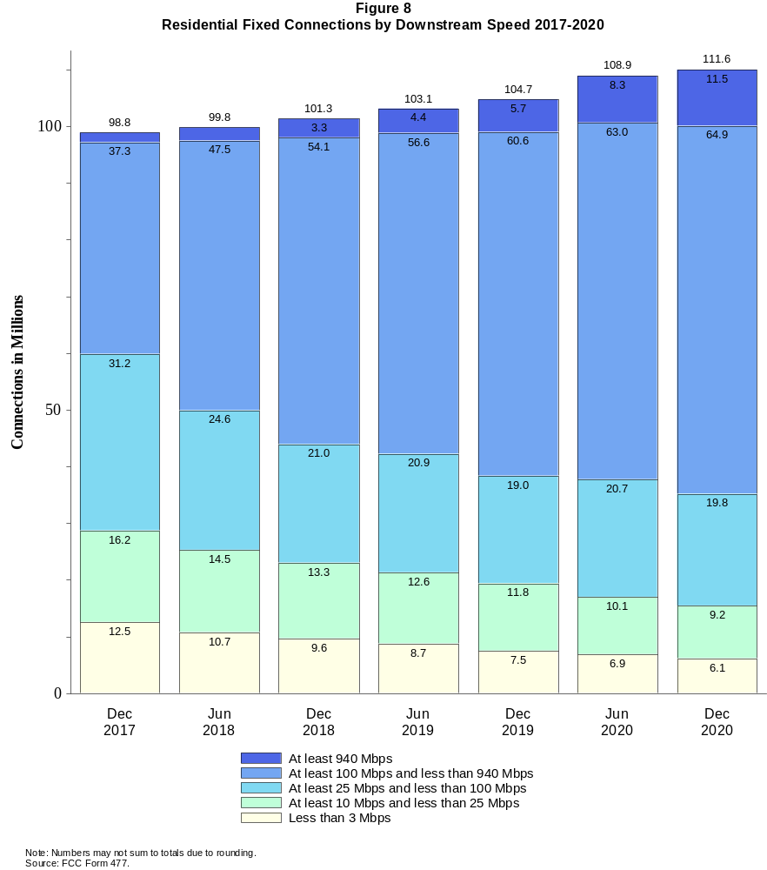

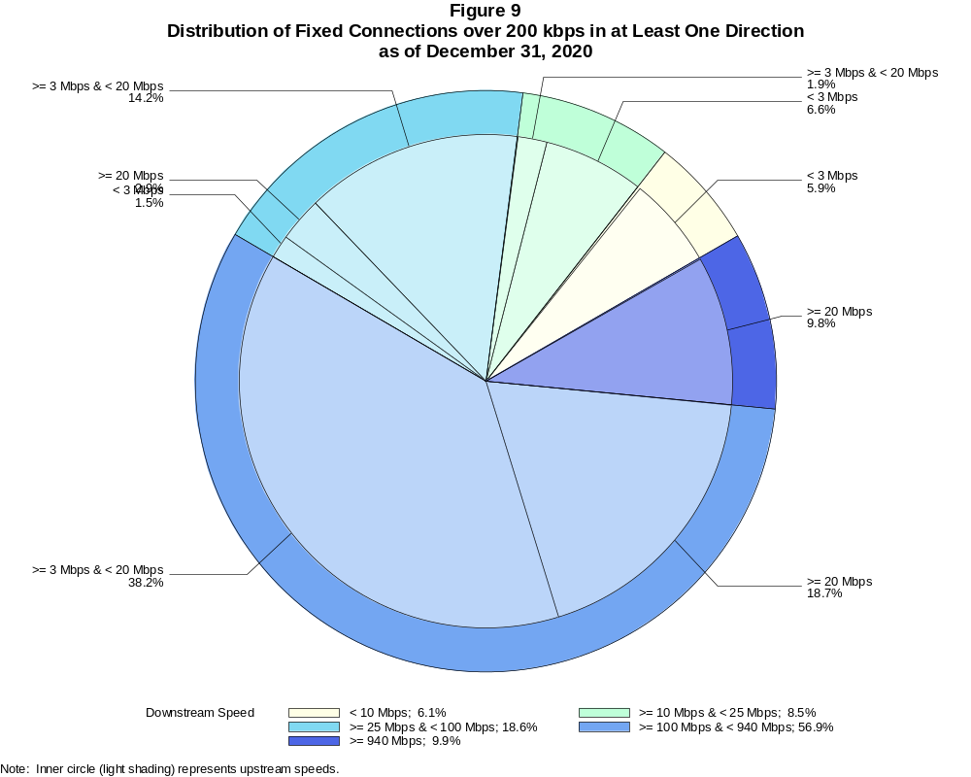

Fixed Connections over 200 kbps in at Least One Direction (in thousands)

 | Downstream Speed
Upstream Speed | Less than 10 Mbps | At least 10 Mbps  and less than 25 Mbps | At least 25 Mbps  and less than 100 Mbps | At least 100 Mbps  and less than 940 Mbps | At least 940 Mbps | Total
Less than 3 Mbps | 7,189 | 7,976 | 1,832 | 38 | 3 | 17,038
At least 3 Mbps & Less than 20 Mbps | 222 | 2,295 | 17,208 | 46,295 | 110 | 66,132
At least 20 Mbps | 2 | 63 | 3,523 | 22,653 | 11,840 | 38,081
Total | 7,414 | 10,334 | 22,563 | 68,986 | 11,953 | 121,250

Percentages

Less than 3 Mbps | 5.9 | 6.6 | 1.5 | 0.0 | 0.0 | 14.1
At least 3 Mbps & Less than 20 Mbps | 0.2 | 1.9 | 14.2 | 38.2 | 0.1 | 54.5
At least 20 Mbps | 0.0 | 0.1 | 2.9 | 18.7 | 9.8 | 31.4
Total | 6.1 | 8.5 | 18.6 | 56.9 | 9.9 | 100.0
Note: Numbers may not sum to totals due to rounding. # = Rounds to zero.
Source: FCC Form 477.

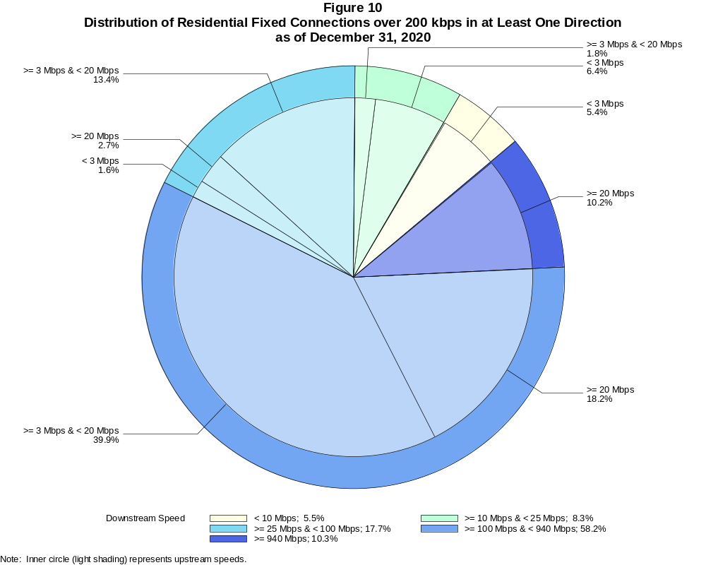

Residential Fixed Connections over 200 kbps in at Least One Direction (in thousands)

 | Downstream Speed
Upstream Speed | Less than 10 Mbps | At least 10 Mbps  and less than 25 Mbps | At least 25 Mbps  and less than 100 Mbps | At least 100 Mbps  and less than 940 Mbps | At least 940 Mbps | Total
Less than 3 Mbps | 5,985 | 7,173 | 1,767 | 37 | 3 | 14,964
At least 3 Mbps & Less than 20 Mbps | 130 | 2,049 | 14,955 | 44,546 | 108 | 61,789
At least 20 Mbps | 1 | 27 | 3,067 | 20,344 | 11,429 | 34,868
Total | 6,115 | 9,249 | 19,790 | 64,927 | 11,540 | 111,621

Percentages

Less than 3 Mbps | 5.4 | 6.4 | 1.6 | 0.0 | 0.0 | 13.4
At least 3 Mbps & Less than 20 Mbps | 0.1 | 1.8 | 13.4 | 39.9 | 0.1 | 55.4
At least 20 Mbps | 0.0 | 0.0 | 2.7 | 18.2 | 10.2 | 31.2
Total | 5.5 | 8.3 | 17.7 | 58.2 | 10.3 | 100.0
Note: Numbers may not sum to totals due to rounding. # = Rounds to zero.
Source: FCC Form 477.

Figure 11
Connections over 200 kbps in at Least One Direction by Technology 2016-2020
(in thousands)

 | 2016 | 2017 |  | 2018 |  | 2019 |  | 2020
Technology | Dec | Jun | Dec | Jun | Dec | Jun | Dec | Jun | Dec
Total | 404,849 | 408,692 | 420,838 | 428,864 | 451,062 | 459,327 | 466,302 | 480,185 | 490,888
Total Fixed | 105,593 | 106,130 | 108,065 | 109,087 | 110,784 | 112,725 | 114,291 | 118,449 | 121,250
aDSL | 26,527 | 25,505 | 24,193 | 23,074 | 22,377 | 21,163 | 20,214 | 19,639 | 18,786
sDSL | 42 | 44 | 28 | 28 | 20 | 17 | 16 | 19 | 13
Other Wireline¹ | 599 | 619 | 581 | 558 | 557 | 501 | 525 | 516 | 527
Cable Modem | 63,325 | 64,060 | 66,196 | 67,165 | 68,882 | 70,750 | 72,516 | 75,986 | 77,909
FTTP² | 11,986 | 12,831 | 13,890 | 14,889 | 15,492 | 16,748 | 17,376 | 18,443 | 19,945
Satellite | 1,864 | 1,826 | 1,872 | 1,939 | 1,971 | 1,984 | 1,975 | 1,993 | 1,931
Fixed Wireless | 1,250 | 1,245 | 1,306 | 1,434 | 1,485 | 1,561 | 1,669 | 1,853 | 2,140
Mobile Wireless | 299,256 | 302,562 | 312,773 | 319,776 | 340,278 | 346,603 | 352,012 | 361,737 | 369,638

¹ Power Line and Other are summarized with Other Wireline for confidentiality reasons. See Technical Notes at the end of the report for a description of
FCC Form 477 technology categories and other reporting requirements.
² Fiber to the premises.
Note: Some previously-published data may have been revised. Numbers may not sum to totals due to rounding.
Source: FCC Form 477.

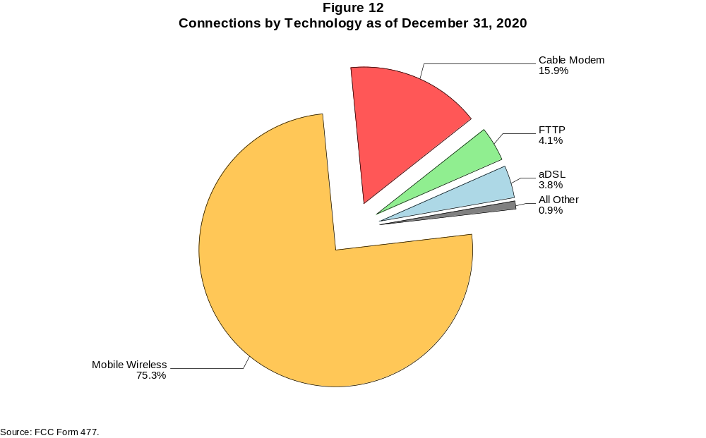

Figure 13
Residential Connections over 200 kbps in at Least One Direction by Technology 2016-2020
(in thousands)

 | 2016 | 2017 |  | 2018 |  | 2019 |  | 2020
Technology | Dec | Jun | Dec | Jun | Dec | Jun | Dec | Jun | Dec
Total | 337,978 | 341,094 | 351,966 | 358,867 | 378,286 | 383,605 | 388,344 | 403,212 | 407,652
Total Fixed | 96,607 | 97,071 | 98,845 | 99,758 | 101,348 | 103,118 | 104,703 | 108,909 | 111,621
aDSL | 23,691 | 22,774 | 21,653 | 20,671 | 20,126 | 18,976 | 18,159 | 17,647 | 16,920
sDSL | 8 | 12 | 9 | 9 | 4 | 4 | 5 | 7 | 3
Other Wireline¹ | 32 | 74 | 67 | 74 | 76 | 62 | 74 | 64 | 59
Cable Modem | 59,145 | 59,687 | 61,567 | 62,320 | 63,813 | 65,457 | 67,141 | 70,710 | 72,543
FTTP² | 10,956 | 11,776 | 12,702 | 13,663 | 14,205 | 15,410 | 16,011 | 16,971 | 18,384
Satellite | 1,676 | 1,637 | 1,688 | 1,751 | 1,787 | 1,805 | 1,795 | 1,815 | 1,752
Fixed Wireless | 1,100 | 1,112 | 1,158 | 1,270 | 1,338 | 1,405 | 1,520 | 1,694 | 1,958
Mobile Wireless | 241,371 | 244,022 | 253,121 | 259,109 | 276,938 | 280,486 | 283,641 | 294,303 | 296,031

¹ Power Line and Other are summarized with Other Wireline for confidentiality reasons. See Technical Notes at the end of the report for a description of
FCC Form 477 technology categories and other reporting requirements.
² Fiber to the premises.
Note: Some previously-published data may have been revised. Numbers may not sum to totals due to rounding.
Source: FCC Form 477.

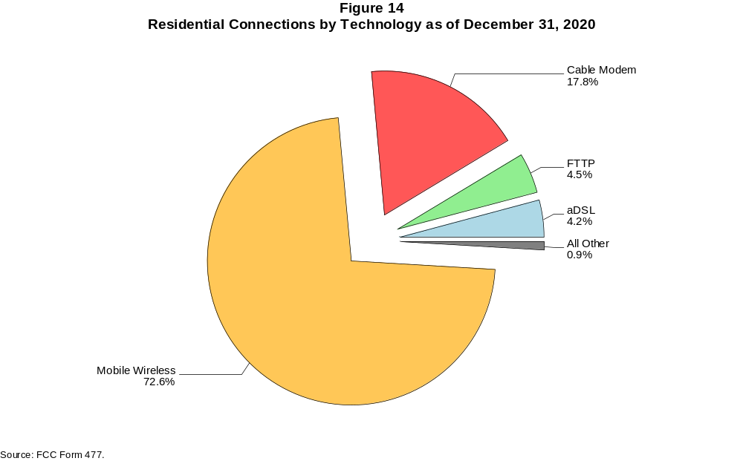

Figure 15
Fixed Connections at Least 10 Mbps Downstream and 1 Mbps Upstream by Technology 2016-2020
(in thousands)

 | 2016 | 2017 |  | 2018 |  | 2019 |  | 2020
Technology | Dec | Jun | Dec | Jun | Dec | Jun | Dec | Jun | Dec
Total | 84,038 | 86,886 | 90,609 | 94,071 | 97,302 | 100,464 | 103,595 | 109,159 | 112,445
aDSL | 10,810 | 11,321 | 11,598 | 11,822 | 12,038 | 11,829 | 11,704 | 12,421 | 11,760
sDSL | 10 | 14 | 9 | 11 | 6 | 5 | 5 | 8 | 4
Other Wireline¹ | 209 | 246 | 262 | 271 | 292 | 261 | 301 | 307 | 323
Cable Modem | 60,349 | 61,704 | 63,978 | 65,808 | 67,716 | 69,704 | 71,934 | 75,391 | 77,513
FTTP² | 10,935 | 11,811 | 12,869 | 13,898 | 14,815 | 16,078 | 16,854 | 17,993 | 19,555
Satellite | 1,342 | 1,373 | 1,402 | 1,595 | 1,677 | 1,726 | 1,737 | 1,778 | 1,727
Fixed Wireless | 383 | 418 | 491 | 666 | 759 | 861 | 1,059 | 1,263 | 1,564

¹ Power Line and Other are summarized with Other Wireline for confidentiality reasons. See Technical Notes at the end of the report for a description of
FCC Form 477 technology categories and other reporting requirements.
² Fiber to the premises.
# = Rounds to zero.
Note: Some previously-published data may have been revised. Numbers may not sum to totals due to rounding.
Source: FCC Form 477.

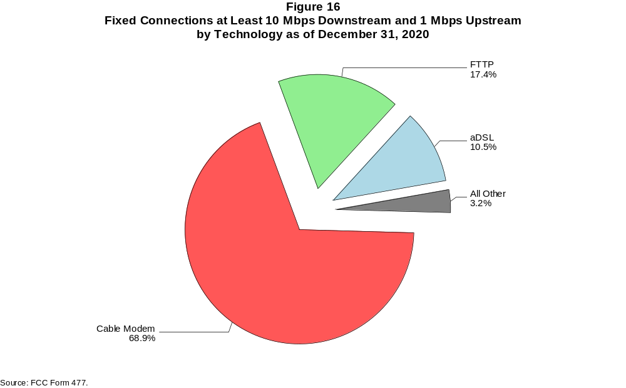

Figure 17
Residential Fixed Connections at Least 10 Mbps Downstream and 1 Mbps Upstream by Technology 2016-2020
(in thousands)

 | 2016 | 2017 |  | 2018 |  | 2019 |  | 2020
Technology | Dec | Jun | Dec | Jun | Dec | Jun | Dec | Jun | Dec
Total | 78,201 | 80,671 | 84,163 | 86,973 | 89,873 | 92,698 | 95,649 | 101,201 | 104,199
aDSL | 9,963 | 10,415 | 10,657 | 10,862 | 11,073 | 10,812 | 10,682 | 11,374 | 10,761
sDSL | 2 | 6 | 5 | 6 | 2 | 1 | 2 | 4 | 1
Other Wireline¹ | 30 | 71 | 64 | 65 | 68 | 58 | 70 | 61 | 56
Cable Modem | 56,538 | 57,617 | 59,864 | 61,142 | 62,810 | 64,556 | 66,691 | 70,299 | 72,215
FTTP² | 10,004 | 10,835 | 11,762 | 12,741 | 13,589 | 14,800 | 15,536 | 16,566 | 18,042
Satellite | 1,333 | 1,362 | 1,387 | 1,575 | 1,655 | 1,702 | 1,708 | 1,745 | 1,691
Fixed Wireless | 332 | 365 | 425 | 582 | 676 | 768 | 960 | 1,151 | 1,433

¹ Power Line and Other are summarized with Other Wireline for confidentiality reasons. See Technical Notes at the end of the report for a description of
FCC Form 477 technology categories and other reporting requirements.
² Fiber to the premises.
# = Rounds to zero.
Note: Some previously-published data may have been revised. Numbers may not sum to totals due to rounding.
Source: FCC Form 477.

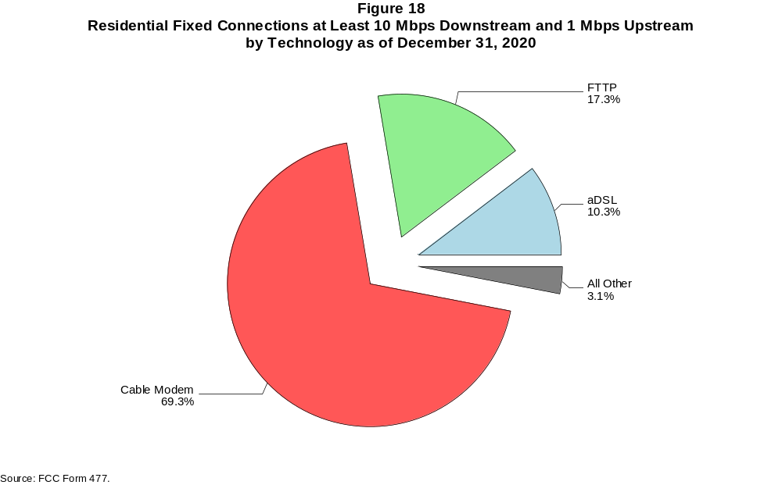

Figure 19
Fixed Connections at Least 25 Mbps Downstream and 3 Mbps Upstream by Technology 2016-2020
(in thousands)

 | 2016 | 2017 |  | 2018 |  | 2019 |  | 2020
Technology | Dec | Jun | Dec | Jun | Dec | Jun | Dec | Jun | Dec
Total | 62,933 | 68,280 | 73,875 | 78,952 | 82,965 | 86,744 | 90,471 | 96,984 | 101,630
aDSL | 1,476 | 2,530 | 3,586 | 4,298 | 4,988 | 5,233 | 5,523 | 5,910 | 6,237
sDSL | * | * | * | * | * | * | * | * | *
Other Wireline¹ | 166 | 203 | 219 | 203 | 228 | 220 | 263 | 273 | 286
Cable Modem | 51,740 | 54,829 | 57,870 | 60,859 | 62,880 | 64,938 | 67,171 | 71,856 | 74,169
FTTP² | 9,422 | 10,344 | 11,489 | 12,568 | 13,605 | 14,902 | 15,866 | 17,076 | 18,840
Satellite | * | * | * | * | * | * | * | * | *
Fixed Wireless | 92 | 120 | 143 | 224 | 267 | 325 | 449 | 571 | 804

¹ Power Line and Other are summarized with Other Wireline for confidentiality reasons. See Technical Notes at the end of the report for a description of
FCC Form 477 technology categories and other reporting requirements.
² Fiber to the premises.
* = Data withheld for confidentiality reasons.
# = Rounds to zero.
Note: Some previously-published data may have been revised. Numbers may not sum to totals due to rounding.
Source: FCC Form 477.

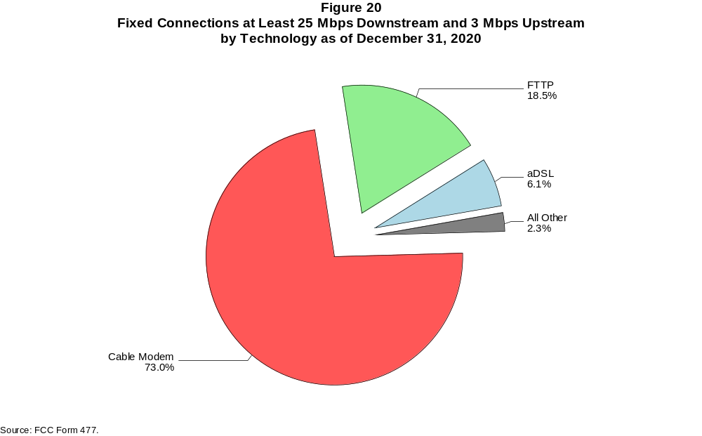

Figure 21
Residential Fixed Connections at Least 25 Mbps Downstream and 3 Mbps Upstream by Technology 2016-2020
(in thousands)

 | 2016 | 2017 |  | 2018 |  | 2019 |  | 2020
Technology | Dec | Jun | Dec | Jun | Dec | Jun | Dec | Jun | Dec
Total | 59,518 | 64,520 | 69,447 | 73,288 | 76,873 | 80,256 | 83,725 | 90,170 | 94,451
aDSL | 1,408 | 2,418 | 3,410 | 4,068 | 4,712 | 4,911 | 5,168 | 5,538 | 5,871
sDSL | * | * | * | * | * | * | * | * | *
Other Wireline¹ | 27 | 67 | 59 | 54 | 61 | 53 | 64 | 56 | 51
Cable Modem | 49,300 | 52,154 | 54,748 | 56,620 | 58,342 | 60,125 | 62,231 | 67,017 | 69,098
FTTP² | 8,674 | 9,532 | 10,553 | 11,570 | 12,546 | 13,780 | 14,690 | 15,781 | 17,445
Satellite | * | * | * | * | * | * | * | * | *
Fixed Wireless | 75 | 101 | 119 | 193 | 234 | 283 | 400 | 512 | 727

¹ Power Line and Other are summarized with Other Wireline for confidentiality reasons. See Technical Notes at the end of the report for a description of
FCC Form 477 technology categories and other reporting requirements.
² Fiber to the premises.
* = Data withheld for confidentiality reasons.
# = Rounds to zero.
Note: Some previously-published data may have been revised. Numbers may not sum to totals due to rounding.
Source: FCC Form 477.

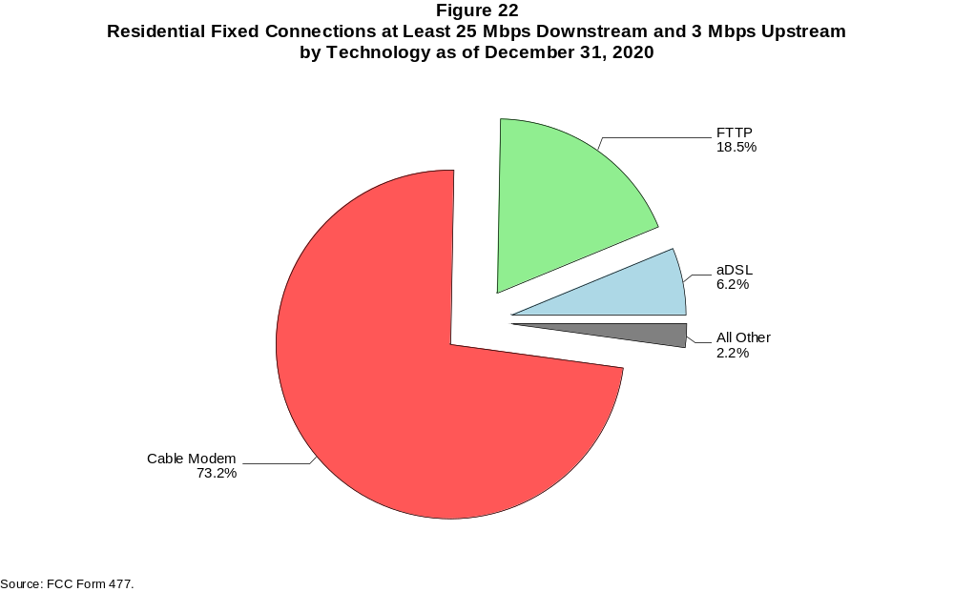

Figure 23
Fixed Connections at Least 100 Mbps Downstream and 20 Mbps Upstream by Technology 2016-2020
(in thousands)

 | 2016 | 2017 |  | 2018 |  | 2019 |  | 2020
Technology | Dec | Jun | Dec | Jun | Dec | Jun | Dec | Jun | Dec
Total | 7,968 | 9,676 | 12,148 | 14,619 | 18,750 | 22,217 | 25,603 | 29,554 | 34,493
aDSL | 2 | 16 | 47 | 59 | 207 | 387 | 569 | 658 | 774
sDSL | 1 | 1 | 1 | 1 | 1 | # | * | * | *
Other Wireline¹ | 140 | 174 | 192 | 174 | 196 | 178 | 211 | 213 | 217
Cable Modem | 5,356 | 6,055 | 7,149 | 8,352 | 9,466 | 11,426 | 13,088 | 15,496 | 18,420
FTTP² | 2,438 | 3,403 | 4,729 | 5,976 | 8,815 | 10,146 | 11,634 | 13,071 | 14,933
Satellite | 0 | 0 | 0 | 0 | 0 | 0 | * | * | *
Fixed Wireless | 31 | 28 | 30 | 56 | 65 | 79 | 101 | 116 | 143

¹ Power Line and Other are summarized with Other Wireline for confidentiality reasons. See Technical Notes at the end of the report for a description of
FCC Form 477 technology categories and other reporting requirements.
² Fiber to the premises.
* = Data withheld for confidentiality reasons.
# = Rounds to zero.
Note: Some previously-published data may have been revised. Numbers may not sum to totals due to rounding.
Source: FCC Form 477.

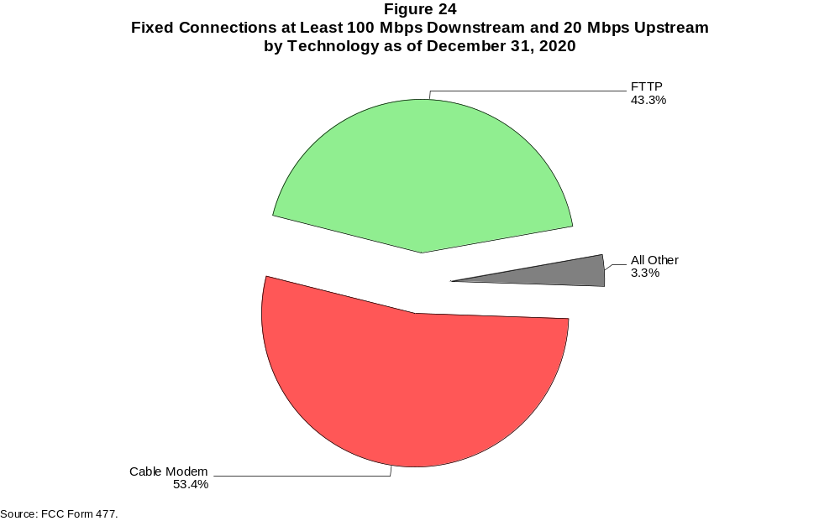

Figure 25
Residential Fixed Connections at Least 100 Mbps Downstream and 20 Mbps Upstream by Technology 2016-2020
(in thousands)

 | 2016 | 2017 |  | 2018 |  | 2019 |  | 2020
Technology | Dec | Jun | Dec | Jun | Dec | Jun | Dec | Jun | Dec
Total | 7,291 | 8,879 | 11,030 | 13,171 | 17,101 | 20,322 | 23,469 | 27,164 | 31,773
aDSL | 2 | 15 | 42 | 53 | 194 | 344 | 512 | 594 | 733
sDSL | # | # | # | # | # | # | * | * | *
Other Wireline¹ | 24 | 61 | 53 | 46 | 47 | 27 | 36 | 27 | 20
Cable Modem | 5,071 | 5,695 | 6,591 | 7,491 | 8,512 | 10,312 | 11,883 | 14,157 | 16,843
FTTP² | 2,170 | 3,089 | 4,324 | 5,534 | 8,292 | 9,574 | 10,952 | 12,288 | 14,055
Satellite | 0 | 0 | 0 | 0 | 0 | 0 | * | * | *
Fixed Wireless | 24 | 20 | 20 | 47 | 56 | 65 | 86 | 98 | 118

¹ Power Line and Other are summarized with Other Wireline for confidentiality reasons. See Technical Notes at the end of the report for a description of
FCC Form 477 technology categories and other reporting requirements.
² Fiber to the premises.
* = Data withheld for confidentiality reasons.
# = Rounds to zero.
Note: Some previously-published data may have been revised. Numbers may not sum to totals due to rounding.
Source: FCC Form 477.

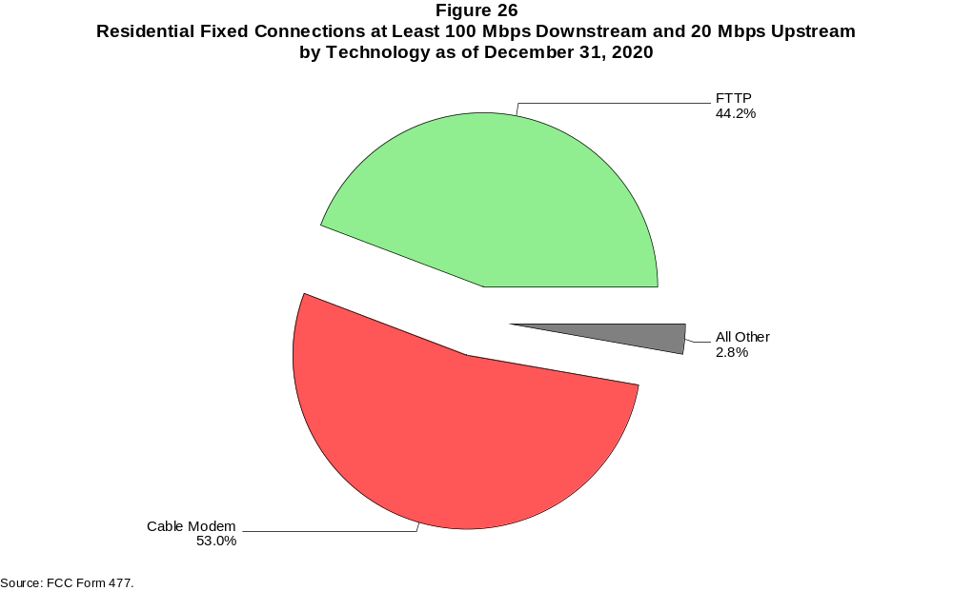

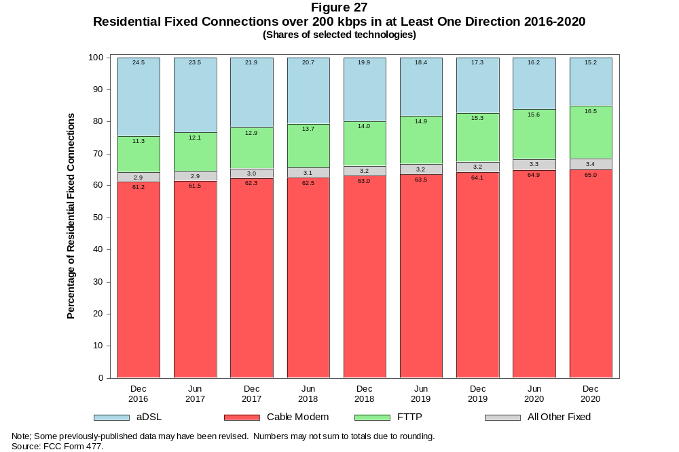

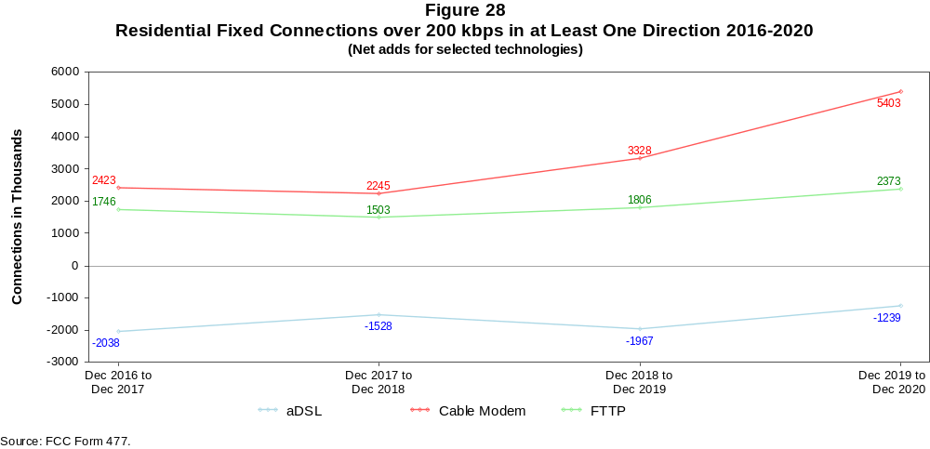

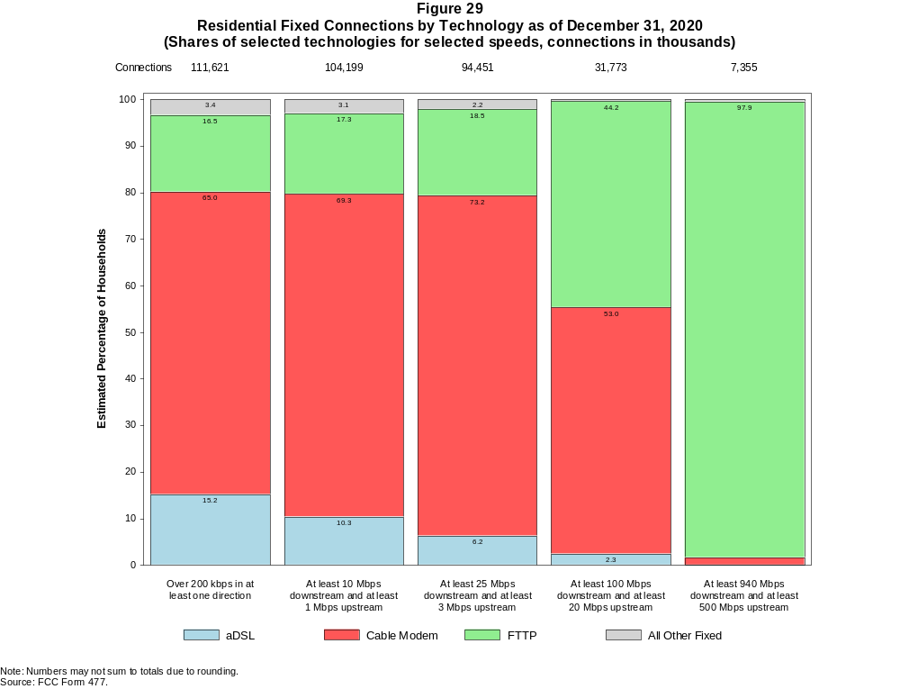

Figure 30
Fixed Connections by Downstream Speed Tier and Technology as of December 31, 2020
(in thousands)

 | Downstream Speed
Technology | Less than  4 Mbps | At least 4 Mbps  and less than  10 Mbps | At least 10 Mbps  and less than  25 Mbps | At least 25 Mbps  and less than  100 Mbps | At least 100 Mbps  and less than  940 Mbps | At least 940 Mbps | Total
aDSL | 2,432 | 3,248 | 6,277 | 5,873 | 955 | # | 18,786
sDSL | * | 1 | * | * | * | * | 13
Other Wireline¹ | 172 | 32 | 33 | 46 | 221 | 23 | 527
Cable Modem | 204 | 183 | 2,136 | 11,099 | 59,956 | 4,329 | 77,909
FTTP | 119 | 234 | 703 | 3,611 | 7,719 | 7,559 | 19,945
Satellite | * | 42 | * | * | * | 0 | 1,931
Fixed Wireless | 202 | 373 | 748 | 660 | 115 | 41 | 2,140
Total | 3,299 | 4,114 | 10,334 | 22,563 | 68,986 | 11,953 | 121,250

Percentages

aDSL | 2.0 | 2.7 | 5.2 | 4.8 | 0.8 | 0.0 | 15.5
sDSL | * | 0.0 | * | * | * | * | 0.0
Other Wireline¹ | 0.1 | 0.0 | 0.0 | 0.0 | 0.2 | 0.0 | 0.4
Cable Modem | 0.2 | 0.2 | 1.8 | 9.2 | 49.4 | 3.6 | 64.3
FTTP | 0.1 | 0.2 | 0.6 | 3.0 | 6.4 | 6.2 | 16.4
Satellite | * | 0.0 | * | * | * | 0.0 | 1.6
Fixed Wireless | 0.2 | 0.3 | 0.6 | 0.5 | 0.1 | 0.0 | 1.8
Total | 2.7 | 3.4 | 8.5 | 18.6 | 56.9 | 9.9 | 100.0

¹ Power Line and Other are summarized with Other Wireline for confidentiality reasons. See Technical Notes at the end of the report for a description of FCC Form 477 technology categories
and other reporting requirements.
# = Rounds to Zero.
* = Data withheld for confidentiality reasons.
Note: Numbers may not sum to totals due to rounding.
Source: FCC Form 477.

Figure 31
Residential Fixed Connections by Downstream Speed Tier and Technology as of December 31, 2020
(in thousands)

 | Downstream Speed
Technology | Less than  4 Mbps | At least 4 Mbps  and less than  10 Mbps | At least 10 Mbps  and less than  25 Mbps | At least 25 Mbps  and less than  100 Mbps | At least 100 Mbps  and less than  940 Mbps | At least 940 Mbps | Total
aDSL | 2,045 | 2,850 | 5,608 | 5,514 | * | * | 16,920
sDSL | * | # | * | * | * | * | 3
Other Wireline¹ | 2 | 1 | 5 | 5 | 27 | 19 | 59
Cable Modem | 183 | 138 | 1,919 | 9,284 | 56,849 | 4,171 | 72,543
FTTP | 96 | 212 | 588 | 3,139 | 7,036 | 7,314 | 18,384
Satellite | * | * | * | * | * | 0 | 1,752
Fixed Wireless | 178 | 347 | 696 | 608 | 93 | 37 | 1,958
Total | 2,527 | 3,589 | 9,249 | 19,790 | 64,927 | 11,540 | 111,621

Percentages

aDSL | 1.8 | 2.6 | 5.0 | 4.9 | * | * | 15.2
sDSL | * | 0.0 | * | * | * | * | 0.0
Other Wireline¹ | 0.0 | 0.0 | 0.0 | 0.0 | 0.0 | 0.0 | 0.1
Cable Modem | 0.2 | 0.1 | 1.7 | 8.3 | 50.9 | 3.7 | 65.0
FTTP | 0.1 | 0.2 | 0.5 | 2.8 | 6.3 | 6.6 | 16.5
Satellite | * | * | * | * | * | 0.0 | 1.6
Fixed Wireless | 0.2 | 0.3 | 0.6 | 0.5 | 0.1 | 0.0 | 1.8
Total | 2.3 | 3.2 | 8.3 | 17.7 | 58.2 | 10.3 | 100.0

¹ Power Line and Other are summarized with Other Wireline for confidentiality reasons. See Technical Notes at the end of the report for a description of FCC Form 477 technology categories
and other reporting requirements.
# = Rounds to Zero.
* = Data withheld for confidentiality reasons.
Note: Numbers may not sum to totals due to rounding.
Source: FCC Form 477.

Figure 32
Nationwide Number of Providers of Connections over 200 kbps in at Least One Direction
by Technology 2016-2020

 | 2016 | 2017 |  | 2018 |  | 2019 |  | 2020
Technology | Dec | Jun | Dec | Jun | Dec | Jun | Dec | Jun | Dec
aDSL | 774 | 768 | 743 | 738 | 721 | 715 | 691 | 677 | 653
sDSL | 160 | 161 | 150 | 136 | 127 | 123 | 121 | 118 | 106
Other Wireline¹ | 236 | 243 | 235 | 249 | 243 | 222 | 211 | 215 | 209
Cable Modem | 385 | 384 | 383 | 372 | 381 | 381 | 373 | 365 | 368
FTTP | 1,066 | 1,103 | 1,147 | 1,183 | 1,269 | 1,309 | 1,330 | 1,377 | 1,441
Satellite | 6 | 5 | 6 | 6 | 6 | 6 | 5 | 5 | 6
Fixed Wireless | 1,071 | 1,095 | 1,160 | 1,188 | 1,239 | 1,248 | 1,280 | 1,312 | 1,396
Mobile Wireless | 98 | 98 | 83 | 73 | 71 | 70 | 67 | 64 | 64
Total | 2,000 | 2,030 | 2,090 | 2,129 | 2,215 | 2,223 | 2,247 | 2,279 | 2,381

¹ Power Line and Other are summarized with Other Wireline for confidentiality reasons.
Note: Multiple FCC Form 477 filers within a holding company structure count as one provider. Some previously-published data may have been revised.
Source: FCC Form 477.

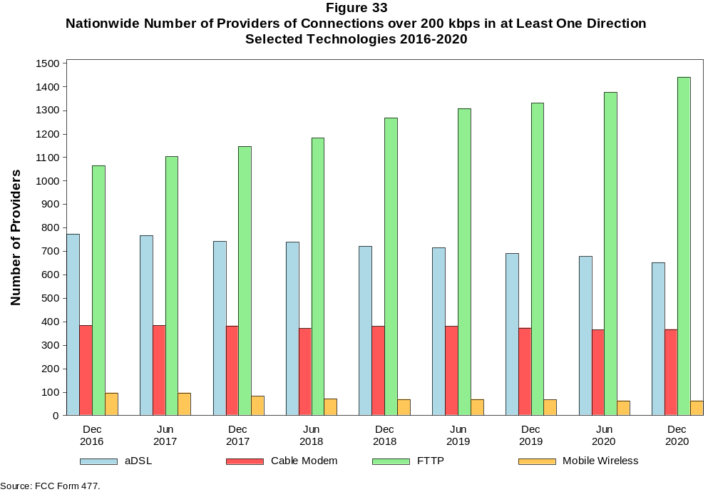

Figure 34
Residential Fixed Connections and Households by State as of December 31, 2020
(Connections and households, in thousands)

 |  | At least 200 kbps in  at least One Direction |  | At least 10 Mbps Down  and 1 Mbps Up |  | At least 25 Mbps Down  and 3 Mbps Up |  | At least 100 Mbps Down  and 20 Mbps Up |  | At least 940 Mbps Down  and 500 Mbps Up
State | Households | Connections | Subscribership  Ratio | Connections | Subscribership  Ratio | Connections | Subscribership  Ratio | Connections | Subscribership  Ratio | Connections | Subscribership  Ratio
Alabama | 1,889 | 1,552 | 0.82 | 1,383 | 0.73 | 1,181 | 0.63 | 377 | 0.20 | 105 | 0.06
Alaska | 255 | 222 | 0.87 | 202 | 0.79 | 152 | 0.59 | * | * | * | *
American Samoa | 10 | * | * | * | * | * | * | 0 | 0.00 | 0 | 0.00
Arizona | 2,643 | 2,444 | 0.92 | 2,205 | 0.83 | 2,013 | 0.76 | 502 | 0.19 | * | *
Arkansas | 1,170 | 906 | 0.77 | 776 | 0.66 | 630 | 0.54 | 218 | 0.19 | 45 | 0.04
California | 13,103 | 12,330 | 0.94 | 11,766 | 0.90 | 10,873 | 0.83 | 2,871 | 0.22 | 500 | 0.04
Colorado | 2,137 | 2,106 | 0.99 | 1,918 | 0.90 | 1,810 | 0.85 | 338 | 0.16 | 100 | 0.05
Connecticut | 1,385 | 1,305 | 0.94 | 1,247 | 0.90 | 1,095 | 0.79 | 347 | 0.25 | 12 | 0.01
Delaware | 371 | 381 | 1.03 | 372 | 1.00 | 367 | 0.99 | 115 | 0.31 | * | *
District of Columbia | 288 | 273 | 0.95 | 266 | 0.92 | 261 | 0.91 | 107 | 0.37 | * | *
Florida | 7,931 | 8,078 | 1.02 | 7,719 | 0.97 | 6,948 | 0.88 | 2,448 | 0.31 | 364 | 0.05
Georgia | 3,830 | 3,470 | 0.91 | 3,231 | 0.84 | 2,804 | 0.73 | 1,172 | 0.31 | 341 | 0.09
Guam | 42 | * | * | * | * | * | * | 0 | 0.00 | 0 | 0.00
Hawaii | 468 | 487 | 1.04 | 472 | 1.01 | * | * | * | * | * | *
Idaho | 649 | 572 | 0.88 | 471 | 0.72 | 381 | 0.59 | 141 | 0.22 | 18 | 0.03
Illinois | 4,884 | 4,201 | 0.86 | 3,951 | 0.81 | 3,350 | 0.69 | 1,181 | 0.24 | 115 | 0.02
Indiana | 2,603 | 2,204 | 0.85 | 2,004 | 0.77 | 1,681 | 0.65 | 621 | 0.24 | 105 | 0.04
Iowa | 1,274 | 1,050 | 0.82 | 899 | 0.71 | 794 | 0.62 | 271 | 0.21 | 25 | 0.02
Kansas | 1,142 | 979 | 0.86 | 894 | 0.78 | 766 | 0.67 | 285 | 0.25 | 104 | 0.09
Kentucky | 1,748 | 1,479 | 0.85 | 1,336 | 0.76 | 1,171 | 0.67 | 382 | 0.22 | 65 | 0.04
Louisiana | 1,752 | 1,427 | 0.81 | 1,303 | 0.74 | 1,117 | 0.64 | 371 | 0.21 | 72 | 0.04
Maine | 570 | 565 | 0.99 | 507 | 0.89 | 423 | 0.74 | 42 | 0.07 | 1 | 0.00
Maryland | 2,231 | 2,135 | 0.96 | 2,078 | 0.93 | 2,025 | 0.91 | 803 | 0.36 | * | *
Massachusetts | 2,647 | 2,522 | 0.95 | 2,451 | 0.93 | 2,417 | 0.91 | 659 | 0.25 | * | *
Michigan | 3,980 | 3,435 | 0.86 | 3,201 | 0.80 | 2,761 | 0.69 | 707 | 0.18 | 65 | 0.02
Minnesota | 2,208 | 1,952 | 0.88 | 1,741 | 0.79 | 1,596 | 0.72 | 308 | 0.14 | 45 | 0.02
Mississippi | 1,117 | 824 | 0.74 | 712 | 0.64 | 534 | 0.48 | 180 | 0.16 | 59 | 0.05
Missouri | 2,440 | 2,039 | 0.84 | 1,799 | 0.74 | 1,559 | 0.64 | 592 | 0.24 | 168 | 0.07
Montana | 436 | 386 | 0.89 | 331 | 0.76 | 284 | 0.65 | 44 | 0.10 | 7 | 0.02
Nebraska | 767 | 656 | 0.86 | 601 | 0.78 | 529 | 0.69 | 170 | 0.22 | 28 | 0.04

Figure 34 - Continued
Residential Fixed Connections and Households by State as of December 31, 2020
(Connections and households, in thousands)

 |  | At least 200 kbps in  at least One Direction |  | At least 10 Mbps Down  and 1 Mbps Up |  | At least 25 Mbps Down  and 3 Mbps Up |  | At least 100 Mbps Down  and 20 Mbps Up |  | At least 940 Mbps Down  and 500 Mbps Up
State | Households | Connections | Subscribership  Ratio | Connections | Subscribership  Ratio | Connections | Subscribership  Ratio | Connections | Subscribership  Ratio | Connections | Subscribership  Ratio
Nevada | 1,130 | 1,071 | 0.95 | 1,016 | 0.90 | 925 | 0.82 | 249 | 0.22 | 31 | 0.03
New Hampshire | 539 | 550 | 1.02 | 522 | 0.97 | 489 | 0.91 | 108 | 0.20 | 2 | 0.00
New Jersey | 3,272 | 3,144 | 0.96 | 3,075 | 0.94 | 3,021 | 0.92 | 1,714 | 0.52 | * | *
New Mexico | 793 | 677 | 0.85 | 548 | 0.69 | 488 | 0.62 | 69 | 0.09 | 5 | 0.01
New York | 7,417 | 6,630 | 0.89 | 6,500 | 0.88 | 6,200 | 0.84 | 3,467 | 0.47 | * | *
North Carolina | 4,032 | 3,784 | 0.94 | 3,446 | 0.85 | 3,214 | 0.80 | 1,064 | 0.26 | 270 | 0.07
North Dakota | 321 | 276 | 0.86 | 266 | 0.83 | 249 | 0.78 | 103 | 0.32 | 3 | 0.01
Northern Mariana Isl | 16 | * | * | * | * | * | * | 0 | 0.00 | 0 | 0.00
Ohio | 4,717 | 4,125 | 0.87 | 3,826 | 0.81 | 3,388 | 0.72 | 781 | 0.17 | * | *
Oklahoma | 1,494 | 1,193 | 0.80 | 1,068 | 0.71 | 904 | 0.61 | 314 | 0.21 | 79 | 0.05
Oregon | 1,643 | 1,488 | 0.91 | 1,354 | 0.82 | 1,263 | 0.77 | 229 | 0.14 | 47 | 0.03
Pennsylvania | 5,107 | 4,537 | 0.89 | 4,238 | 0.83 | 4,080 | 0.80 | 1,222 | 0.24 | * | *
Puerto Rico | 1,206 | 673 | 0.56 | 586 | 0.49 | 355 | 0.29 | 108 | 0.09 | 4 | 0.00
Rhode Island | 415 | 393 | 0.95 | 390 | 0.94 | 381 | 0.92 | 204 | 0.49 | * | *
South Carolina | 1,961 | 1,790 | 0.91 | 1,678 | 0.86 | 1,489 | 0.76 | 493 | 0.25 | 73 | 0.04
South Dakota | 348 | 297 | 0.85 | 285 | 0.82 | 271 | 0.78 | 84 | 0.24 | 1 | 0.00
Tennessee | 2,640 | 2,274 | 0.86 | 2,129 | 0.81 | 1,867 | 0.71 | 777 | 0.29 | 204 | 0.08
Texas | 9,906 | 8,996 | 0.91 | 8,547 | 0.86 | 7,725 | 0.78 | 3,154 | 0.32 | 935 | 0.09
Utah | 1,003 | 948 | 0.95 | 870 | 0.87 | 803 | 0.80 | 218 | 0.22 | 68 | 0.07
Vermont | 263 | 262 | 1.00 | 226 | 0.86 | 187 | 0.71 | 33 | 0.12 | * | *
Virgin Islands | 43 | * | * | * | * | * | * | * | * | 0 | 0.00
Virginia | 3,184 | 2,864 | 0.90 | 2,689 | 0.84 | 2,572 | 0.81 | 1,025 | 0.32 | * | *
Washington | 2,906 | 2,715 | 0.93 | 2,488 | 0.86 | 2,345 | 0.81 | 414 | 0.14 | 104 | 0.04
West Virginia | 734 | 572 | 0.78 | 468 | 0.64 | 401 | 0.55 | 119 | 0.16 | 2 | 0.00
Wisconsin | 2,378 | 2,090 | 0.88 | 1,899 | 0.80 | 1,652 | 0.69 | 301 | 0.13 | 46 | 0.02
Wyoming | 233 | 206 | 0.89 | 183 | 0.79 | 164 | 0.70 | 18 | 0.08 | 1 | 0.00
Total | 123,671 | 111,621 | 0.90 | 104,199 | 0.84 | 94,451 | 0.76 | 31,773 | 0.26 | 7,355 | 0.06

# = Rounds to Zero; * = Data withheld for confidentiality reasons.
Note: Numbers may not sum to totals due to rounding.
Sources: FCC Form 477 (Connections); 2016-2020 ACS 5-year estimates; Census 2010.

Figure 35
Connections by Type of End User by State as of December 31, 2020
(Connections over 200 kbps in at least one direction, in thousands)

 | Connections |  | Percentages
State | Residential | Business | Residential | Business | Total
Alabama | 5,692 | 1,416 | 80.1 | 19.9 | 7,108
Alaska | 862 | 137 | 86.3 | 13.7 | 0
American Samoa | * | * | * | * | *
Arizona | 8,697 | 1,508 | 85.2 | 14.8 | 10,205
Arkansas | 3,311 | 861 | 79.4 | 20.6 | 4,172
California | 50,789 | 9,896 | 83.7 | 16.3 | 60,686
Colorado | 7,085 | 1,464 | 82.9 | 17.1 | 8,549
Connecticut | 4,631 | 925 | 83.4 | 16.6 | 5,556
Delaware | 1,257 | 248 | 83.5 | 16.5 | 1,505
District of Columbia | 1,056 | 597 | 63.9 | 36.1 | 1,653
Florida | 28,001 | 4,841 | 85.3 | 14.7 | 32,842
Georgia | 12,885 | 2,965 | 81.3 | 18.7 | 15,850
Guam | * | * | * | * | *
Hawaii | 1,829 | 353 | 83.8 | 16.2 | 2,182
Idaho | 2,032 | 400 | 83.6 | 16.4 | 2,432
Illinois | 15,810 | 3,315 | 82.7 | 17.3 | 19,125
Indiana | 7,687 | 1,568 | 83.1 | 16.9 | 9,256
Iowa | 3,572 | 792 | 81.8 | 18.2 | 4,365
Kansas | 3,429 | 704 | 83.0 | 17.0 | 4,133
Kentucky | 5,246 | 918 | 85.1 | 14.9 | 6,164
Louisiana | 5,701 | 1,020 | 84.8 | 15.2 | 6,721
Maine | 1,512 | 461 | 76.6 | 23.4 | 1,973
Maryland | 7,883 | 1,369 | 85.2 | 14.8 | 9,252
Massachusetts | 8,718 | 1,748 | 83.3 | 16.7 | 10,466
Michigan | 12,095 | 2,407 | 83.4 | 16.6 | 14,502
Minnesota | 6,691 | 1,429 | 82.4 | 17.6 | 8,121
Mississippi | 3,412 | 664 | 83.7 | 16.3 | 4,076
Missouri | 7,240 | 1,445 | 83.4 | 16.6 | 8,685
Montana | 1,172 | 333 | 77.9 | 22.1 | 1,505
Nebraska | 2,182 | 592 | 78.6 | 21.4 | 2,774
Nevada | 3,953 | 576 | 87.3 | 12.7 | 4,529
New Hampshire | 1,626 | 407 | 80.0 | 20.0 | 2,033
New Jersey | 11,931 | 2,162 | 84.7 | 15.3 | 14,093
New Mexico | 2,514 | 460 | 84.5 | 15.5 | 2,974
New York | 25,332 | 5,510 | 82.1 | 17.9 | 30,841
North Carolina | 12,178 | 2,841 | 81.1 | 18.9 | 15,020
North Dakota | 871 | 232 | 79.0 | 21.0 | 1,102
Northern Mariana Isl | * | * | * | * | *
Ohio | 14,178 | 3,039 | 82.3 | 17.7 | 17,217
Oklahoma | 4,662 | 849 | 84.6 | 15.4 | 5,512
Oregon | 5,094 | 1,060 | 82.8 | 17.2 | 6,155
Pennsylvania | 15,377 | 3,312 | 82.3 | 17.7 | 18,689
Puerto Rico | 2,864 | 1,158 | 71.2 | 28.8 | 4,022
Rhode Island | 1,367 | 287 | 82.6 | 17.4 | 1,654
South Carolina | 5,871 | 1,325 | 81.6 | 18.4 | 7,196
South Dakota | 952 | 259 | 78.6 | 21.4 | 1,211
Tennessee | 8,009 | 1,855 | 81.2 | 18.8 | 9,864
Texas | 36,878 | 6,305 | 85.4 | 14.6 | 43,182
Utah | 3,527 | 728 | 82.9 | 17.1 | 4,255
Vermont | 705 | 231 | 75.3 | 24.7 | 937
Virgin Islands | 121 | 10 | 92.4 | 7.6 | 131
Virginia | 10,230 | 2,363 | 81.2 | 18.8 | 12,594
Washington | 9,397 | 1,888 | 83.3 | 16.7 | 11,286
West Virginia | 1,948 | 345 | 84.9 | 15.1 | 2,294
Wisconsin | 6,648 | 1,398 | 82.6 | 17.4 | 8,047
Wyoming | 669 | 178 | 78.9 | 21.1 | 847
Total | 407,652 | 83,237 | 83.0 | 17.0 | 490,888
# = Rounds to Zero.
* = Data withheld for confidentiality reasons.
Note: Numbers may not sum to totals due to rounding.
Source: FCC Form 477.

Figure 36
Connections by Technology by State as of December 31, 2020
(Connections over 200 kbps in at least one direction, in thousands)

State | ADSL | SDSL | Other  Wireline¹ | Cable  Modem | Fiber | Satellite | Fixed  Wireless | Mobile  Wireless | Total
Alabama | 397 | * | 5 | 949 | 257 | * | 16 | 5,422 | 7,108
Alaska | 66 | # | 7 | * | 13 | * | 13 | 743 | 0
American Samoa | 0 | 0 | 0 | * | * | 0 | * | * | *
Arizona | 568 | * | 12 | 1,754 | 181 | * | 63 | 7,588 | 10,205
Arkansas | 323 | * | 2 | 460 | 133 | * | 15 | 3,187 | 4,172
California | 2,229 | 2 | * | 9,293 | 1,527 | * | 202 | 47,224 | 60,686
Colorado | * | # | 18 | 1,534 | 203 | * | 96 | 6,270 | 8,549
Connecticut | * | * | 2 | 1,141 | 43 | * | * | * | 5,556
Delaware | * | * | 2 | 272 | * | * | 1 | * | 1,505
District of Columbia | * | * | 6 | * | * | * | 4 | * | 1,653
Florida | 1,176 | * | 20 | 6,131 | 1,306 | * | 32 | 24,093 | 32,842
Georgia | 792 | * | 10 | 2,197 | 696 | * | 16 | 12,067 | 15,850
Guam | * | 0 | 0 | * | * | 0 | * | * | *
Hawaii | * | * | 1 | * | 73 | * | 2 | 1,644 | 2,182
Idaho | 200 | * | 3 | 279 | 55 | * | 66 | 1,811 | 2,432
Illinois | 898 | # | * | 3,153 | 317 | * | 114 | 14,586 | 19,125
Indiana | 494 | * | 3 | 1,377 | 394 | * | 62 | * | 9,256
Iowa | 269 | 1 | * | 511 | 269 | * | 58 | 3,225 | 4,365
Kansas | 196 | # | * | 540 | 256 | * | 51 | 3,070 | 4,133
Kentucky | 341 | * | 2 | 898 | 298 | * | 27 | 4,560 | 6,164
Louisiana | 353 | * | 4 | 923 | 200 | * | 17 | 5,166 | 6,721
Maine | 107 | 1 | * | 471 | 20 | * | 10 | 1,352 | 1,973
Maryland | * | * | 16 | 1,313 | * | * | 8 | 6,950 | 9,252
Massachusetts | * | * | 17 | 2,078 | * | * | 17 | * | 10,466
Michigan | 656 | * | 5 | 2,699 | 184 | * | 65 | 10,805 | 14,502
Minnesota | 440 | 1 | * | 1,308 | 276 | * | 49 | 6,013 | 8,121
Mississippi | 320 | * | 9 | 397 | 105 | * | 16 | 3,164 | 4,076
Missouri | 547 | # | * | 1,113 | 406 | * | 59 | 6,482 | 8,685
Montana | 92 | * | 2 | 244 | 45 | * | 34 | 1,073 | 1,505
Nebraska | 125 | # | * | 403 | 136 | * | 41 | 2,058 | 2,774

Figure 36 - Continued
Connections by Technology by State as of December 31, 2020
(Connections over 200 kbps in at least one direction, in thousands)

State | ADSL | SDSL | Other  Wireline¹ | Cable  Modem | Fiber | Satellite | Fixed  Wireless | Mobile  Wireless | Total
Nevada | 161 | # | 6 | * | 99 | * | 45 | 3,371 | 4,529
New Hampshire | 59 | # | * | 499 | 37 | * | 3 | 1,426 | 2,033
New Jersey | 89 | * | 24 | 2,194 | * | * | 3 | * | 14,093
New Mexico | 223 | * | 4 | 406 | 50 | * | 32 | 2,241 | 2,974
New York | 219 | * | 36 | 5,074 | 1,884 | * | 16 | 23,566 | 30,841
North Carolina | 635 | * | 8 | 2,735 | 606 | * | 24 | 10,935 | 15,020
North Dakota | 29 | * | 1 | 170 | 105 | * | 4 | 792 | 1,102
Northern Mariana Isl | * | * | * | * | * | 0 | * | * | *
Ohio | 805 | * | 10 | 3,075 | 424 | * | 71 | * | 17,217
Oklahoma | 305 | # | * | 655 | 222 | * | 68 | 4,208 | 5,512
Oregon | 203 | # | 14 | 1,123 | 211 | 30 | 41 | 4,534 | 6,155
Pennsylvania | 412 | # | * | 3,347 | 1,074 | * | 19 | 13,773 | 18,689
Puerto Rico | * | 0 | * | * | 56 | * | 51 | 3,295 | 4,022
Rhode Island | * | * | * | * | * | * | # | * | 1,654
South Carolina | 354 | * | 3 | 1,233 | 308 | * | 9 | 5,250 | 7,196
South Dakota | 36 | * | 1 | 194 | 78 | * | 12 | 884 | 1,211
Tennessee | 400 | # | * | 1,405 | 579 | * | 23 | 7,395 | 9,864
Texas | 1,648 | # | * | 5,473 | 2,083 | * | 321 | 33,420 | 43,182
Utah | 158 | * | 7 | 603 | 201 | * | 53 | 3,227 | 4,255
Vermont | 78 | * | 3 | 171 | 34 | * | 3 | 641 | 937
Virgin Islands | * | 0 | 0 | * | * | * | * | * | 131
Virginia | 219 | # | * | 1,727 | 1,034 | * | 31 | 9,479 | 12,594
Washington | 371 | # | 45 | 2,146 | 256 | 46 | 53 | 8,369 | 11,286
West Virginia | * | * | 1 | 407 | 16 | * | 7 | 1,670 | 2,294
Wisconsin | 507 | * | 3 | * | 219 | * | 53 | 5,788 | 8,047
Wyoming | 44 | * | 1 | 128 | 15 | * | 36 | 616 | 847
Total | 18,786 | 13 | 527 | 77,909 | 19,945 | 1,931 | 2,140 | 369,638 | 490,888

¹ PowerLine and Other are summarized with Other Wireline for confidentiality reasons. See Technical Notes at the end of the report for a description of FCC Form 477 technology categories and
other reporting requirements.
# = Rounds to Zero.
* = Data withheld for confidentiality reasons.
Note: Numbers may not sum to totals due to rounding.
Source: FCC Form 477.

Figure 37
Percentage of Fixed Connections by Downstream Speed by State as of December 31, 2020

 | Over 200 kbps Upstream and
State | % over 200 kbps  Downstream | % at least 10 Mbps  Downstream | % at least 25 Mbps  Downstream | % at least 100 Mbps  Downstream | % at least 940 Mbps  Downstream
Alabama | 99.8 | 90.3 | 78.9 | 59.4 | 7.9
Alaska | 99.7 | 89.3 | 68.4 | * | *
American Samoa | * | * | * | * | *
Arizona | 99.8 | 94.5 | 83.1 | 58.5 | 9.5
Arkansas | 99.9 | 88.1 | 71.0 | 41.1 | 7.6
California | 99.8 | 94.6 | 87.0 | 68.2 | 8.3
Colorado | 99.9 | 95.2 | 86.2 | 63.3 | 12.1
Connecticut | 99.7 | 94.7 | 84.3 | 72.9 | 5.5
Delaware | 100.0 | 96.9 | 95.5 | 80.2 | 18.6
District of Columbia | 100.0 | 95.2 | 93.3 | 79.0 | 20.0
Florida | 99.8 | 96.3 | 90.2 | 70.3 | 6.7
Georgia | 99.6 | 92.9 | 84.3 | 63.6 | 12.4
Guam | * | * | * | * | *
Hawaii | 100.0 | 95.6 | * | * | *
Idaho | 99.9 | 90.2 | 68.4 | 47.9 | 5.0
Illinois | 99.8 | 93.6 | 84.4 | 62.8 | 6.6
Indiana | 99.6 | 91.5 | 80.5 | 58.3 | 7.0
Iowa | 99.5 | 90.0 | 76.7 | 52.5 | 8.0
Kansas | 99.8 | 92.0 | 77.6 | 53.0 | 13.0
Kentucky | 99.7 | 90.4 | 79.9 | 60.2 | 5.3
Louisiana | 99.8 | 91.7 | 79.2 | 55.0 | 8.6
Maine | 99.2 | 88.3 | 75.3 | 63.8 | 1.4
Maryland | 99.9 | 96.5 | 93.9 | 77.8 | 20.9
Massachusetts | 100.0 | 96.5 | 95.0 | 83.6 | 15.4
Michigan | 99.6 | 92.9 | 84.3 | 63.9 | 4.2
Minnesota | 99.9 | 93.0 | 82.4 | 59.5 | 6.4
Mississippi | 99.7 | 86.6 | 68.2 | 41.3 | 9.1
Missouri | 99.7 | 90.5 | 77.3 | 59.7 | 9.9
Montana | 99.9 | 90.1 | 74.6 | 54.6 | 2.1
Nebraska | 99.6 | 93.3 | 80.9 | 59.7 | 7.3

Figure 37 - Continued
Percentage of Fixed Connections by Downstream Speed by State as of December 31, 2020

 | Over 200 kbps Upstream and
State | % over 200 kbps  Downstream | % at least 10 Mbps  Downstream | % at least 25 Mbps  Downstream | % at least 100 Mbps  Downstream | % at least 940 Mbps  Downstream
Nevada | 99.9 | 96.0 | 87.4 | 64.9 | 10.3
New Hampshire | 99.5 | 93.1 | 88.1 | 78.2 | 7.7
New Jersey | 99.8 | 97.3 | 95.2 | 83.6 | 20.8
New Mexico | 99.9 | 88.6 | 73.6 | 45.0 | 4.3
New York | 99.8 | 97.2 | 92.7 | 82.7 | 13.0
North Carolina | 99.4 | 92.8 | 84.9 | 71.0 | 7.5
North Dakota | 99.9 | 96.7 | 89.1 | 69.8 | 5.5
Northern Mariana Isl | * | * | * | * | *
Ohio | 99.8 | 93.1 | 82.0 | 64.7 | 3.2
Oklahoma | 99.7 | 89.5 | 74.8 | 51.2 | 10.6
Oregon | 99.9 | 93.8 | 85.1 | 64.4 | 8.8
Pennsylvania | 99.9 | 93.7 | 89.7 | 71.8 | 13.4
Puerto Rico | 100.0 | 85.6 | 52.9 | 25.1 | 0.7
Rhode Island | 99.6 | 98.5 | 95.7 | 80.3 | 23.3
South Carolina | 99.8 | 93.8 | 84.2 | 68.6 | 5.1
South Dakota | 99.8 | 97.1 | 91.2 | 63.6 | 4.1
Tennessee | 99.7 | 93.7 | 85.3 | 66.1 | 11.0
Texas | 99.9 | 95.0 | 85.5 | 65.6 | 13.4
Utah | 100.0 | 95.1 | 85.1 | 62.6 | 13.4
Vermont | 98.5 | 84.3 | 73.1 | 59.7 | 8.1
Virgin Islands | * | * | * | * | *
Virginia | 99.6 | 93.9 | 89.0 | 72.4 | 19.1
Washington | 99.8 | 94.4 | 86.7 | 67.8 | 11.5
West Virginia | 97.9 | 81.1 | 69.3 | 53.4 | 5.5
Wisconsin | 99.3 | 92.2 | 79.4 | 62.4 | 2.7
Wyoming | 99.9 | 92.1 | 79.8 | 53.1 | 1.0
Total | 99.8 | 93.9 | 85.4 | 66.8 | 9.9

Source: FCC Form 477.

Figure 38
Providers of Connections by Technology by State as of December 31, 2020
(Connections over 200 kbps in at least one direction, in thousands)

State | ADSL | SDSL | Other  Wireline¹ | Cable  Modem | Fiber | Satellite | Fixed  Wireless | Mobile  Wireless | Total
Alabama | 23 | * | 15 | 18 | 45 | * | 30 | 6 | 82
Alaska | 17 | 4 | 9 | * | 19 | * | 15 | 10 | 38
American Samoa | 0 | 0 | 0 | * | * | 0 | * | * | *
Arizona | 19 | * | 18 | 16 | 50 | * | 53 | 5 | 101
Arkansas | 22 | * | 13 | 17 | 47 | * | 36 | 4 | 90
California | 32 | 12 | * | 32 | 94 | * | 131 | 4 | 222
Colorado | * | 5 | 20 | 16 | 77 | * | 75 | 8 | 139
Connecticut | * | * | 9 | 9 | 22 | * | * | * | 34
Delaware | * | * | 6 | 5 | * | * | 4 | * | 27
District of Columbia | * | * | 12 | * | * | * | 8 | * | 37
Florida | 17 | * | 24 | 18 | 78 | * | 47 | 6 | 121
Georgia | 25 | * | 18 | 26 | 91 | * | 31 | 4 | 121
Guam | * | 0 | 0 | * | * | 0 | * | * | *
Hawaii | * | * | 9 | * | 10 | * | 9 | 4 | 20
Idaho | 23 | * | 15 | 16 | 42 | * | 46 | 7 | 77
Illinois | 49 | 5 | * | 21 | 98 | * | 99 | 5 | 185
Indiana | 36 | * | 21 | 12 | 81 | * | 75 | * | 130
Iowa | 71 | 12 | * | 40 | 179 | * | 93 | 6 | 237
Kansas | 27 | 5 | * | 22 | 74 | * | 84 | 8 | 139
Kentucky | 16 | * | 10 | 28 | 60 | * | 36 | 6 | 109
Louisiana | 16 | * | 16 | 15 | 41 | * | 26 | 5 | 75
Maine | 12 | 6 | * | 7 | 20 | * | 19 | 4 | 43
Maryland | * | * | 19 | 16 | * | * | 28 | 4 | 76
Massachusetts | * | * | 12 | 11 | * | * | 21 | * | 60
Michigan | 26 | * | 25 | 26 | 82 | * | 66 | 6 | 140
Minnesota | 38 | 7 | * | 20 | 92 | * | 65 | 4 | 139
Mississippi | 14 | * | 10 | 12 | 37 | * | 16 | 5 | 67
Missouri | 31 | 4 | * | 17 | 76 | * | 87 | 6 | 146
Montana | 19 | * | 12 | 7 | 38 | * | 44 | 6 | 70
Nebraska | 27 | 5 | * | 18 | 63 | * | 54 | 6 | 105

Figure 38 - Continued
Providers of Connections by Technology by State as of December 31, 2020
(Connections over 200 kbps in at least one direction, in thousands)

State | ADSL | SDSL | Other  Wireline¹ | Cable  Modem | Fiber | Satellite | Fixed  Wireless | Mobile  Wireless | Total
Nevada | 17 | 4 | 15 | * | 43 | * | 34 | 4 | 75
New Hampshire | 9 | 4 | * | 5 | 22 | * | 13 | 4 | 37
New Jersey | 8 | * | 20 | 8 | * | * | 11 | * | 63
New Mexico | 18 | * | 14 | 10 | 39 | * | 45 | 5 | 73
New York | 28 | * | 27 | 22 | 80 | * | 31 | 4 | 115
North Carolina | 19 | * | 20 | 27 | 64 | * | 31 | 5 | 102
North Dakota | 18 | * | 9 | 9 | 34 | * | 15 | 5 | 51
Northern Mariana Isl | * | * | * | * | * | 0 | * | * | *
Ohio | 32 | * | 25 | 32 | 88 | * | 77 | * | 165
Oklahoma | 33 | 5 | * | 14 | 62 | * | 60 | 9 | 118
Oregon | 32 | 6 | 21 | 18 | 66 | 4 | 51 | 5 | 109
Pennsylvania | 21 | 4 | * | 27 | 71 | * | 39 | 6 | 124
Puerto Rico | * | 0 | * | * | 13 | * | 30 | 4 | 41
Rhode Island | * | * | * | * | * | * | 4 | * | 24
South Carolina | 18 | * | 14 | 14 | 40 | * | 19 | 5 | 62
South Dakota | 20 | * | 11 | 9 | 42 | * | 25 | 7 | 76
Tennessee | 20 | 4 | * | 20 | 84 | * | 36 | 5 | 117
Texas | 62 | 8 | * | 32 | 139 | * | 176 | 8 | 273
Utah | 20 | * | 15 | 11 | 39 | * | 39 | 7 | 70
Vermont | 8 | * | 8 | 5 | 20 | * | 12 | 5 | 36
Virgin Islands | * | 0 | 0 | * | * | * | * | * | 6
Virginia | 19 | 4 | * | 20 | 78 | * | 48 | 5 | 118
Washington | 25 | 5 | 28 | 25 | 75 | 4 | 55 | 5 | 118
West Virginia | * | * | 8 | 16 | 29 | * | 23 | 5 | 66
Wisconsin | 40 | * | 20 | * | 75 | * | 53 | 5 | 116
Wyoming | 14 | * | 9 | 7 | 23 | * | 22 | 7 | 46
Total | 653 | 106 | 209 | 368 | 1,441 | 6 | 1,396 | 64 | 2,381

¹ Power Line and Other are summarized with Other Wireline for confidentiality reasons. See Technical Notes at the end of the report for a description of FCC Form 477 technology categories and
other reporting requirements.
# = Rounds to Zero.
* = Data withheld for confidentiality reasons.
Note: Numbers may not sum to totals due to rounding.
Source: FCC Form 477.

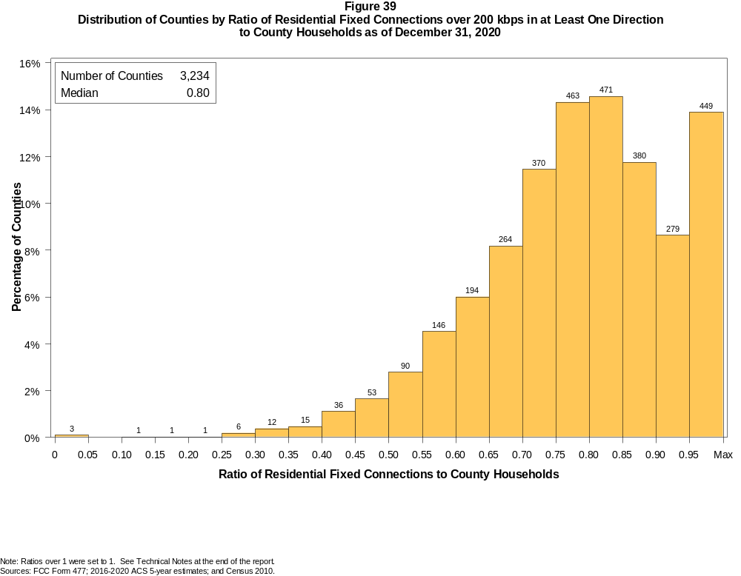

Figure 40
Distribution of Counties by Ratio of Residential Fixed Connections over 200 kbps in at Least One Direction
to County Households by Technology as of December 31, 2020

 | Ratio of Residential Fixed Connections to County Households
Technology | Zero | Greater than 0 and no more than 5% | Greater than 5 and no more than 10% | Greater than 10 and no more than 20% | Greater than 20 and no more than 30% | Greater than 30 and no more than 40% | Greater than 40 and no more than 50% | Greater than 50 and no more than 60% | Greater than 60 and no more than 80% | Greater than 80 and no more than 100% | 100% or more
aDSL | 1.9 | 9.6 | 12.9 | 30.7 | 22.6 | 12.5 | 5.4 | 2.3 | 1.7 | 0.3 | 0.1
sDSL | 95.8 | 4.1 | 0.0 | 0.0 | 0.0 | 0.0 | 0.0 | 0.0 | 0.0 | 0.0 | 0.0
Other Wireline¹ | 82.3 | 17.6 | 0.0 | 0.1 | 0.0 | 0.0 | 0.0 | 0.0 | 0.0 | 0.0 | 0.0
Cable Modem | 11.3 | 5.9 | 5.2 | 11.1 | 12.7 | 11.3 | 11.5 | 11.0 | 16.2 | 2.9 | 0.8
FTTP | 10.3 | 39.7 | 13.5 | 13.5 | 7.8 | 4.6 | 3.3 | 2.4 | 4.1 | 0.6 | 0.1
Satellite | 0.4 | 65.5 | 21.4 | 11.2 | 1.1 | 0.3 | 0.0 | 0.0 | 0.0 | 0.0 | 0.0
Fixed Wireless | 3.5 | 65.4 | 15.1 | 10.0 | 3.8 | 1.2 | 0.6 | 0.2 | 0.1 | 0.0 | 0.1
Total | 0.1 | 0.0 | 0.0 | 0.1 | 0.2 | 0.8 | 2.8 | 7.3 | 39.9 | 41.4 | 7.4

¹ Power Line and Other are summarized with Other Wireline. See Technical Notes at the end of the report for a description of FCC Form 477 technology categories and other reporting requirements.
Note: Numbers may not sum to totals due to rounding.
Sources: FCC Form 477; 2016-2020 ACS 5-year estimates; and Census 2010.

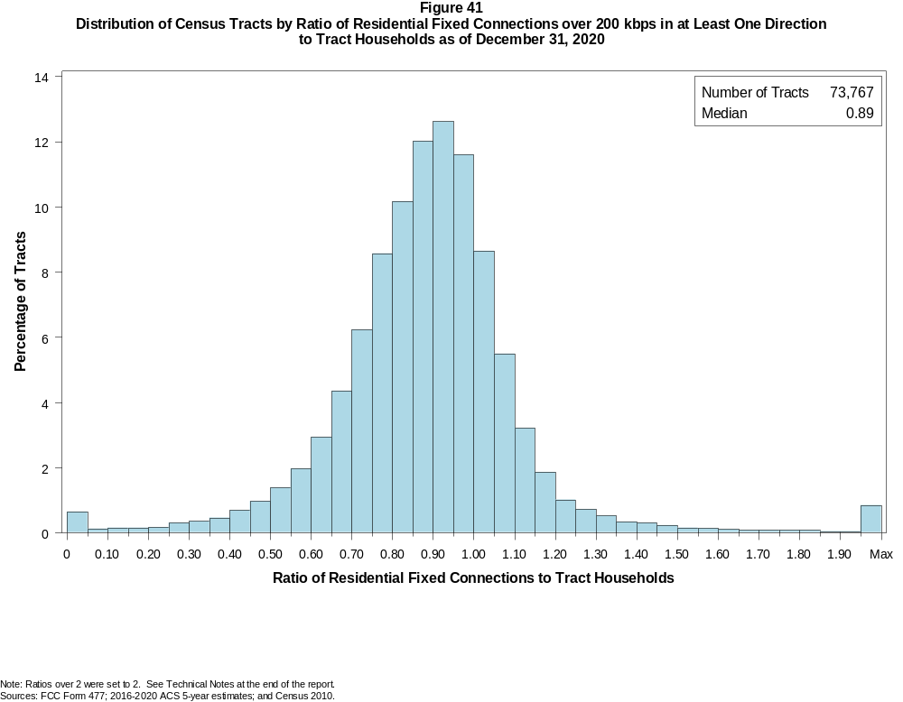

Figure 42
Distribution of Census Tracts by Ratio of Residential Fixed Connections over 200 kbps in at Least One Direction
to Tract Households by Technology as of December 31, 2020

 | Ratio of Residential Fixed Connections to Tract Households
Technology | Zero | Greater than 0 and no more than 5% | Greater than 5 and no more than 10% | Greater than 10 and no more than 20% | Greater than 20 and no more than 30% | Greater than 30 and no more than 40% | Greater than 40 and no more than 50% | Greater than 50 and no more than 60% | Greater than 60 and no more than 80% | Greater than 80 and no more than 100% | 100% or more
aDSL | 5.2 | 28.0 | 16.2 | 24.6 | 15.0 | 5.8 | 2.6 | 1.2 | 0.9 | 0.2 | 0.2
sDSL | 99.4 | 0.5 | 0.0 | 0.0 | 0.0 | 0.0 | 0.0 | 0.0 | 0.0 | 0.0 | 0.0
Other Wireline¹ | 96.9 | 2.9 | 0.1 | 0.0 | 0.0 | 0.0 | 0.0 | 0.0 | 0.0 | 0.0 | 0.0
Cable Modem | 4.3 | 2.6 | 1.5 | 3.2 | 4.3 | 6.8 | 11.8 | 16.5 | 32.2 | 13.2 | 3.6
FTTP | 28.0 | 24.1 | 8.5 | 11.7 | 8.5 | 6.5 | 4.9 | 3.3 | 3.3 | 0.8 | 0.3
Satellite | 28.7 | 61.3 | 5.3 | 3.6 | 0.8 | 0.2 | 0.1 | 0.0 | 0.0 | 0.0 | 0.0
Fixed Wireless | 31.3 | 60.1 | 3.5 | 2.9 | 1.1 | 0.5 | 0.3 | 0.1 | 0.1 | 0.0 | 0.1
Total | 0.6 | 0.1 | 0.1 | 0.3 | 0.5 | 0.8 | 1.7 | 3.4 | 22.1 | 46.5 | 24.0

¹ Power Line and Other are summarized with Other Wireline. See Technical Notes at the end of the report for a description of FCC Form 477 technology categories and other reporting requirements.
Note: Numbers may not sum to totals due to rounding.
Sources: FCC Form 477; 2016-2020 ACS 5-year estimates; and Census 2010.

Figure 43
Percentage of Developed Census Blocks with Residential Fixed Service by Technology as of December 31, 2020
(Internet Access Service over 200 kbps in at least one direction)

 | Number of Providers
Technology | Zero | One | Two | Three | Four | Five | Six | Seven or More
aDSL | 23.9 | 74.2 | 1.8 | 0.1 | 0.0 | 0.0 | 0.0 | 0.0
sDSL | 99.7 | 0.3 | 0.0 | 0.0 | 0.0 | 0.0 | 0.0 | 0.0
Other Wireline¹ | 99.3 | 0.7 | 0.0 | 0.0 | 0.0 | 0.0 | 0.0 | 0.0
Cable Modem | 30.9 | 65.0 | 4.0 | 0.0 | 0.0 | 0.0 | 0.0 | 0.0
FTTP | 69.9 | 28.6 | 1.4 | 0.1 | 0.0 | 0.0 | 0.0 | 0.0
Satellite | 0.0 | 0.1 | 1.0 | 98.8 | 0.1 | 0.0 | 0.0 | 0.0
Fixed Wireless | 28.3 | 32.9 | 20.8 | 11.1 | 4.8 | 1.6 | 0.4 | 0.2
aDSL and/or Cable Modem and/or FTTP | 9.9 | 24.3 | 56.1 | 9.1 | 0.6 | 0.0 | 0.0 | 0.0
Any Technology | 0.0 | 0.1 | 0.0 | 2.7 | 9.7 | 26.6 | 28.9 | 32.0

¹ Power Line and Other are summarized with Other Wireline. See Technical Notes at the end of the report for a description of FCC Form 477 technology categories and other reporting requirements.
Note: Numbers may not sum to totals due to rounding. The number of providers in a census block does not necessarily reflect the number of choices available to a particular household, and does not
purport to measure competition. Providers may list a census block on FCC Form 477 if service can be provided to at least one location in the block. Developed census blocks are those with housing units
based on the 2010 census.
Sources: FCC Form 477 and Census 2010.

Figure 44
Distribution of Counties by Ratio of Residential Fixed Connections to County Households by State as of December 31, 2020
(Connections over 200 kbps in at least one direction)

 |  | Ratio of Residential Fixed Connections over 200 kbps in at Least One Direction to County Households
State | Counties | Zero | Greater than 0 and no more than 5% | Greater than 5 and no more than 10% | Greater than 10 and no more than 20% | Greater than 20 and no more than 30% | Greater than 30 and no more than 40% | Greater than 40 and no more than 50% | Greater than 50 and no more than 60% | Greater than 60 and no more than 80% | Greater than 80 and no more than 100% | 100% or more
Alabama | 67 | 0 | 0 | 0 | 0 | 0 | 0 | 3 | 11 | 34 | 18 | 1
Alaska | 29 | 0 | 0 | 0 | 0 | 1 | 0 | 1 | 4 | 6 | 12 | 5
American Samoa | 5 | 2 | 0 | 0 | 0 | 0 | 0 | 0 | 2 | 1 | 0 | 0
Arizona | 15 | 0 | 0 | 0 | 0 | 0 | 0 | 0 | 1 | 4 | 10 | 0
Arkansas | 75 | 0 | 0 | 0 | 0 | 0 | 0 | 5 | 20 | 39 | 11 | 0
California | 58 | 0 | 0 | 0 | 0 | 0 | 0 | 0 | 1 | 5 | 46 | 6
Colorado | 64 | 0 | 0 | 0 | 0 | 0 | 1 | 2 | 3 | 14 | 25 | 19
Connecticut | 8 | 0 | 0 | 0 | 0 | 0 | 0 | 0 | 0 | 0 | 8 | 0
Delaware | 3 | 0 | 0 | 0 | 0 | 0 | 0 | 0 | 0 | 0 | 2 | 1
District of Columbia | 1 | 0 | 0 | 0 | 0 | 0 | 0 | 0 | 0 | 0 | 1 | 0
Florida | 67 | 0 | 0 | 0 | 0 | 0 | 0 | 0 | 2 | 16 | 25 | 24
Georgia | 159 | 0 | 0 | 0 | 0 | 1 | 3 | 7 | 21 | 60 | 53 | 14
Guam | 1 | 0 | 0 | 0 | 0 | 0 | 0 | 0 | 0 | 0 | 1 | 0
Hawaii | 5 | 0 | 0 | 0 | 1 | 0 | 0 | 0 | 0 | 0 | 1 | 3
Idaho | 44 | 0 | 0 | 0 | 0 | 0 | 1 | 3 | 1 | 17 | 16 | 6
Illinois | 102 | 0 | 0 | 0 | 0 | 0 | 1 | 2 | 11 | 54 | 33 | 1
Indiana | 92 | 0 | 0 | 0 | 0 | 0 | 0 | 0 | 6 | 55 | 30 | 1
Iowa | 99 | 0 | 0 | 0 | 0 | 0 | 0 | 0 | 0 | 62 | 36 | 1
Kansas | 105 | 0 | 0 | 0 | 0 | 0 | 0 | 0 | 4 | 65 | 36 | 0
Kentucky | 120 | 0 | 0 | 0 | 0 | 0 | 0 | 1 | 13 | 58 | 48 | 0
Louisiana | 64 | 0 | 0 | 0 | 0 | 0 | 1 | 4 | 15 | 26 | 18 | 0
Maine | 16 | 0 | 0 | 0 | 0 | 0 | 0 | 0 | 0 | 0 | 9 | 7
Maryland | 24 | 0 | 0 | 0 | 0 | 0 | 0 | 0 | 0 | 3 | 19 | 2
Massachusetts | 14 | 0 | 0 | 0 | 0 | 0 | 0 | 0 | 0 | 0 | 10 | 4
Michigan | 83 | 0 | 0 | 0 | 0 | 0 | 0 | 0 | 3 | 31 | 43 | 6
Minnesota | 87 | 0 | 0 | 0 | 0 | 0 | 0 | 1 | 0 | 26 | 57 | 3
Mississippi | 82 | 0 | 0 | 0 | 0 | 0 | 1 | 13 | 23 | 35 | 9 | 1
Missouri | 115 | 0 | 0 | 0 | 0 | 0 | 2 | 5 | 12 | 63 | 30 | 3
Montana | 56 | 0 | 0 | 0 | 0 | 0 | 0 | 0 | 1 | 21 | 30 | 4
Nebraska | 93 | 0 | 0 | 0 | 0 | 0 | 0 | 1 | 5 | 56 | 31 | 0

Figure 44 - Continued
Distribution of Counties by Ratio of Residential Fixed Connections to County Households by State as of December 31, 2020
(Connections over 200 kbps in at least one direction)

 |  | Ratio of Residential Fixed Connections over 200 kbps in at Least One Direction to County Households
State | Counties | Zero | Greater than 0 and no more than 5% | Greater than 5 and no more than 10% | Greater than 10 and no more than 20% | Greater than 20 and no more than 30% | Greater than 30 and no more than 40% | Greater than 40 and no more than 50% | Greater than 50 and no more than 60% | Greater than 60 and no more than 80% | Greater than 80 and no more than 100% | 100% or more
Nevada | 17 | 0 | 0 | 0 | 0 | 0 | 0 | 2 | 1 | 5 | 8 | 1
New Hampshire | 10 | 0 | 0 | 0 | 0 | 0 | 0 | 0 | 0 | 0 | 5 | 5
New Jersey | 21 | 0 | 0 | 0 | 0 | 0 | 0 | 1 | 0 | 0 | 17 | 3
New Mexico | 33 | 0 | 0 | 0 | 0 | 0 | 0 | 0 | 2 | 12 | 13 | 6
New York | 62 | 0 | 0 | 0 | 0 | 0 | 0 | 1 | 0 | 8 | 43 | 10
North Carolina | 100 | 0 | 0 | 0 | 0 | 0 | 0 | 0 | 1 | 29 | 52 | 18
North Dakota | 53 | 0 | 0 | 0 | 0 | 0 | 0 | 0 | 0 | 23 | 27 | 3
Northern Mariana Isl | 4 | 1 | 0 | 0 | 0 | 0 | 1 | 1 | 1 | 0 | 0 | 0
Ohio | 88 | 0 | 0 | 0 | 0 | 0 | 0 | 0 | 2 | 33 | 51 | 2
Oklahoma | 77 | 0 | 0 | 0 | 0 | 0 | 0 | 5 | 12 | 46 | 13 | 1
Oregon | 36 | 0 | 0 | 0 | 0 | 0 | 0 | 1 | 2 | 8 | 21 | 4
Pennsylvania | 67 | 0 | 0 | 0 | 0 | 0 | 0 | 1 | 0 | 18 | 45 | 3
Puerto Rico | 78 | 0 | 0 | 0 | 0 | 4 | 12 | 17 | 24 | 19 | 2 | 0
Rhode Island | 5 | 0 | 0 | 0 | 0 | 0 | 0 | 0 | 0 | 0 | 3 | 2
South Carolina | 46 | 0 | 0 | 0 | 1 | 1 | 0 | 0 | 2 | 20 | 18 | 4
South Dakota | 66 | 0 | 0 | 0 | 0 | 0 | 1 | 0 | 1 | 36 | 26 | 2
Tennessee | 95 | 0 | 0 | 0 | 0 | 0 | 0 | 0 | 4 | 50 | 37 | 4
Texas | 254 | 0 | 0 | 0 | 0 | 0 | 1 | 4 | 14 | 121 | 97 | 17
Utah | 29 | 0 | 0 | 0 | 0 | 0 | 0 | 0 | 0 | 2 | 19 | 8
Vermont | 14 | 0 | 0 | 0 | 0 | 0 | 0 | 0 | 0 | 0 | 8 | 6
Virgin Islands | 3 | 0 | 0 | 0 | 0 | 0 | 0 | 0 | 0 | 2 | 1 | 0
Virginia | 134 | 0 | 0 | 0 | 0 | 0 | 2 | 6 | 8 | 45 | 62 | 11
Washington | 39 | 0 | 0 | 0 | 0 | 0 | 0 | 1 | 0 | 10 | 22 | 6
West Virginia | 55 | 0 | 0 | 0 | 0 | 0 | 0 | 1 | 2 | 34 | 18 | 0
Wisconsin | 72 | 0 | 0 | 0 | 0 | 0 | 0 | 0 | 0 | 14 | 48 | 10
Wyoming | 23 | 0 | 0 | 0 | 0 | 0 | 0 | 0 | 1 | 5 | 15 | 2
Total | 3,234 | 3 | 0 | 0 | 2 | 7 | 27 | 89 | 236 | 1291 | 1339 | 240

Note: Numbers may not sum to totals due to rounding. See Technical Notes at the end of the report.
Sources: FCC Form 477; 2016-2020 ACS 5-year estimates (Households for U.S. and District of Columbia); Census 2010 (Households for Puerto Rico, American Samoa,
Guam, Northern Mariana Islands and U.S. Virgin Islands).

Figure 45
Distribution of Census Tracts by Ratio of Residential Fixed Connections to Tract Households by State as of December 31, 2020
(Connections over 200 kbps in at least one direction)

 |  | Ratio of Residential Fixed Connections over 200 kbps in at Least One Direction to Tract Households
State | Tracts | Zero | Greater than 0 and no more than 5% | Greater than 5 and no more than 10% | Greater than 10 and no more than 20% | Greater than 20 and no more than 30% | Greater than 30 and no more than 40% | Greater than 40 and no more than 50% | Greater than 50 and no more than 60% | Greater than 60 and no more than 80% | Greater than 80 and no more than 100% | 100% or more
Alabama | 1,179 | 0 | 0 | 1 | 0 | 3 | 28 | 64 | 106 | 392 | 428 | 157
Alaska | 167 | 1 | 0 | 0 | 2 | 2 | 4 | 5 | 6 | 38 | 72 | 37
American Samoa | 18 | 2 | 0 | 0 | 0 | 0 | 1 | 3 | 5 | 5 | 0 | 2
Arizona | 1,526 | 9 | 2 | 3 | 7 | 15 | 18 | 23 | 46 | 286 | 619 | 498
Arkansas | 686 | 0 | 0 | 0 | 1 | 5 | 13 | 56 | 91 | 268 | 192 | 60
California | 8,036 | 46 | 10 | 3 | 10 | 16 | 32 | 45 | 88 | 997 | 4,519 | 2,270
Colorado | 1,249 | 8 | 0 | 0 | 2 | 1 | 3 | 10 | 20 | 130 | 626 | 449
Connecticut | 829 | 3 | 0 | 0 | 0 | 1 | 0 | 3 | 1 | 91 | 478 | 252
Delaware | 215 | 1 | 0 | 0 | 0 | 0 | 1 | 0 | 2 | 28 | 98 | 85
District of Columbia | 179 | 0 | 0 | 1 | 1 | 0 | 0 | 0 | 2 | 28 | 85 | 62
Florida | 4,199 | 29 | 4 | 3 | 2 | 5 | 9 | 19 | 73 | 531 | 1,577 | 1,947
Georgia | 1,964 | 6 | 0 | 2 | 2 | 2 | 23 | 43 | 103 | 467 | 782 | 534
Guam | 56 | 8 | 1 | 1 | 3 | 5 | 1 | 2 | 4 | 7 | 8 | 16
Hawaii | 326 | 10 | 1 | 1 | 1 | 1 | 1 | 2 | 3 | 33 | 122 | 151
Idaho | 298 | 0 | 0 | 0 | 0 | 3 | 4 | 9 | 12 | 89 | 135 | 46
Illinois | 3,121 | 5 | 0 | 0 | 5 | 7 | 22 | 52 | 132 | 853 | 1,592 | 453
Indiana | 1,508 | 5 | 1 | 0 | 4 | 1 | 11 | 22 | 94 | 503 | 644 | 223
Iowa | 825 | 2 | 0 | 0 | 0 | 1 | 0 | 9 | 20 | 380 | 354 | 59
Kansas | 770 | 6 | 0 | 1 | 2 | 4 | 6 | 5 | 37 | 274 | 313 | 122
Kentucky | 1,115 | 7 | 0 | 2 | 0 | 3 | 10 | 32 | 58 | 348 | 499 | 156
Louisiana | 1,136 | 10 | 1 | 0 | 3 | 12 | 23 | 66 | 93 | 345 | 388 | 195
Maine | 351 | 0 | 0 | 0 | 0 | 0 | 0 | 0 | 0 | 46 | 174 | 131
Maryland | 1,394 | 6 | 1 | 1 | 1 | 2 | 2 | 17 | 16 | 197 | 660 | 491
Massachusetts | 1,471 | 12 | 1 | 1 | 1 | 2 | 4 | 6 | 11 | 168 | 854 | 411
Michigan | 2,767 | 25 | 2 | 4 | 4 | 18 | 29 | 46 | 123 | 687 | 1,329 | 500
Minnesota | 1,335 | 4 | 0 | 0 | 0 | 1 | 5 | 6 | 18 | 330 | 782 | 189
Mississippi | 661 | 4 | 0 | 0 | 0 | 6 | 17 | 64 | 106 | 241 | 162 | 61
Missouri | 1,393 | 2 | 1 | 0 | 2 | 7 | 16 | 54 | 87 | 431 | 579 | 214
Montana | 271 | 1 | 0 | 0 | 0 | 0 | 1 | 4 | 7 | 79 | 131 | 48
Nebraska | 532 | 3 | 1 | 0 | 0 | 1 | 0 | 2 | 16 | 180 | 259 | 70

Figure 45 - Continued
Distribution of Census Tracts by Ratio of Residential Fixed Connections to Tract Households by State as of December 31, 2020
(Connections over 200 kbps in at least one direction)

 |  | Ratio of Residential Fixed Connections over 200 kbps in at Least One Direction to Tract Households
State | Tracts | Zero | Greater than 0 and no more than 5% | Greater than 5 and no more than 10% | Greater than 10 and no more than 20% | Greater than 20 and no more than 30% | Greater than 30 and no more than 40% | Greater than 40 and no more than 50% | Greater than 50 and no more than 60% | Greater than 60 and no more than 80% | Greater than 80 and no more than 100% | 100% or more
Nevada | 683 | 4 | 0 | 0 | 1 | 0 | 2 | 8 | 17 | 103 | 334 | 214
New Hampshire | 294 | 2 | 0 | 0 | 0 | 0 | 0 | 0 | 1 | 10 | 152 | 129
New Jersey | 2,004 | 9 | 1 | 0 | 8 | 8 | 19 | 12 | 10 | 229 | 962 | 746
New Mexico | 499 | 1 | 1 | 2 | 2 | 7 | 4 | 13 | 24 | 156 | 204 | 85
New York | 4,900 | 68 | 3 | 6 | 15 | 19 | 20 | 33 | 62 | 1,124 | 2,445 | 1,105
North Carolina | 2,183 | 12 | 1 | 0 | 0 | 0 | 3 | 11 | 53 | 505 | 931 | 667
North Dakota | 205 | 0 | 0 | 0 | 0 | 0 | 1 | 0 | 6 | 80 | 85 | 33
Northern Mariana Isl | 22 | 2 | 0 | 0 | 0 | 1 | 5 | 6 | 1 | 3 | 4 | 0
Ohio | 2,946 | 5 | 0 | 0 | 4 | 6 | 15 | 41 | 102 | 800 | 1,532 | 441
Oklahoma | 1,046 | 0 | 2 | 2 | 3 | 9 | 25 | 51 | 121 | 359 | 330 | 144
Oregon | 827 | 2 | 1 | 0 | 1 | 0 | 1 | 3 | 18 | 135 | 513 | 153
Pennsylvania | 3,217 | 18 | 2 | 3 | 5 | 4 | 16 | 32 | 73 | 717 | 1,702 | 645
Puerto Rico | 903 | 13 | 8 | 46 | 127 | 126 | 127 | 126 | 77 | 84 | 46 | 123
Rhode Island | 241 | 0 | 0 | 1 | 0 | 0 | 0 | 1 | 1 | 20 | 141 | 77
South Carolina | 1,097 | 9 | 2 | 8 | 2 | 10 | 9 | 28 | 65 | 274 | 401 | 289
South Dakota | 222 | 0 | 0 | 1 | 1 | 0 | 0 | 4 | 7 | 101 | 86 | 22
Tennessee | 1,497 | 12 | 1 | 0 | 2 | 6 | 14 | 28 | 71 | 501 | 629 | 233
Texas | 5,253 | 28 | 2 | 1 | 5 | 14 | 26 | 88 | 233 | 1,445 | 2,125 | 1,286
Utah | 588 | 2 | 2 | 0 | 1 | 3 | 2 | 1 | 3 | 76 | 309 | 189
Vermont | 184 | 1 | 0 | 0 | 0 | 0 | 0 | 1 | 1 | 13 | 106 | 62
Virgin Islands | 29 | 0 | 0 | 0 | 1 | 0 | 2 | 3 | 0 | 16 | 6 | 1
Virginia | 1,895 | 18 | 2 | 1 | 2 | 7 | 24 | 37 | 74 | 373 | 825 | 532
Washington | 1,446 | 2 | 0 | 1 | 1 | 2 | 4 | 6 | 11 | 150 | 899 | 370
West Virginia | 484 | 0 | 0 | 0 | 2 | 4 | 8 | 24 | 39 | 189 | 171 | 47
Wisconsin | 1,393 | 2 | 2 | 0 | 0 | 1 | 3 | 6 | 22 | 362 | 796 | 199
Wyoming | 132 | 1 | 0 | 1 | 0 | 0 | 0 | 2 | 1 | 32 | 72 | 23
Total | 73,767 | 426 | 56 | 97 | 236 | 351 | 614 | 1,234 | 2,473 | 16,309 | 34,267 | 17,704

Note: Numbers may not sum to totals due to rounding. See Technical Notes at the end of the report.
Sources: FCC Form 477; 2016-2020 ACS 5-year estimates (Households for U.S. and District of Columbia); Census 2010 (Households for Puerto Rico, American Samoa,
Guam, Northern Mariana Islands and U.S. Virgin Islands).

